PRINCIPLES OF INTERNET PROGRAMMING

(IT205N)

**ASSIGNMENT 2**

**SESSION : JANUARY – APRIL 2018**

**

|  |  |  |  |  |  |
| --- | --- | --- | --- | --- | --- |
| **NAME** | |  | | --- | | 1. NG YUAN SHEN | | 1. NICOLAS CHNG WEI LIANG | | 1. CHIN SEE YING | | 1. TAN CHONG HOW | |
| **STUDENT NUMBER** | |  | | --- | | 1. SCPG1600751 | | 1. SCPG1600690 | | 1. SCPG1700011 | | 1. SCPG1600150 | |
| **INSTRUCTOR** | ANG JIAN XIANG (Ryan) |

**Student Particulars**

|  |  |  |  |  |  |  |
| --- | --- | --- | --- | --- | --- | --- |
| Name | : | |  | | --- | | 1. NG YUAN SHEN | | 1. NICOLAS CHNG WEI LIANG | | 1. CHIN SEE YING | | 1. TAN CHONG HOW | |
| IC Number | : | |  | | --- | | 1. 991004-07-5721 | | 1. 961024-56-5181 | | 1. 990128-07-6094 | | 1. 971030-07-5073 | |
| Student Number | : | |  | | --- | | 1. SCPG1600751 | | 1. SCPG1600690 | | 1. SCPG1700011 | | 1. SCPG1600150 | |
| Course Programme | : | DIIT |
| Intake | : | JAN 2017 |
| Subject Title | : | PRINCIPLES OF INTERNET PROGRAMMING |
| Subject Code | : | IT205N |
| Assignment Title | : | ASSIGNMENT 2 (GROUP ASSIGNMENT) |
| Name of Lecturer | : | MR ANG JIAN XIANG |
| Due Date | : | 11th April 2018, 6.00pm |
| College | : | SEGI COLLEGE, PENANG |

**Declaration by students:**

We, NG YUAN SHEN, NICOLAS CHNG WEI LIANG, CHIN SEE YING, TAN CHONG HOW, hereby declare that the attached assignment is our own work and understand that if we are suspected of plagiarism or another form of cheating; our work will be referred to the lecturer who may, as a result recommend to the Examinations Board that my enrolment in the programme be discontinued.

**18.4.18**

**_________________ _____________________**

**Date Signature of students**

**Assignment Allocation of Marks**

|  |  |  |  |
| --- | --- | --- | --- |
| **No.** | **Description of criteria** | **Weightings** | **Marks Allotted by Lecturer** |
| **1** | **PART A** | 90% |  |
|  | **Documentation**: | 35% |  |
|  | * Cover page, table of content | 1% |  |
|  | * System wireframe | 5% |  |
|  | * Interface design | 5% |  |
|  | * Database design | 15% |  |
|  | * System screenshots | 5% |  |
|  | * References | 2% |  |
|  | * Report formatting | 2% |  |
|  | **System**: | 55% |  |
|  | * Usability or Robustness | 10% |  |
|  | * Adequacy/ Completeness | 30% |  |
|  | * HCI Consideration | 5% |  |
|  | * Error Handling/ Data Validation | 5% |  |
|  | * Design Quality | 5% |  |
| **2** | **PART B** | 10% |  |
|  | Presentation Skill | 2% |  |
|  | Presentation Content (PowerPoint slides and system demonstration) | 5% |  |
|  | Question and Answer (Q&A) | 1% |  |
|  | Language | 0.5% |  |
|  | Self-Confidence | 0.5% |  |
|  | Team Work | 1% |  |
|  | **Total Mark** | 100% |  |
|  | **Total Mark in 20%** | 20% |  |

**Comment:**

__________________________________________________________________________________________________________________________________________

__________________________________________________________________________________________________________________________________________

Lecturer’s Name : Ang Jian Xiang

Date :

|  |  |  |  |  |
| --- | --- | --- | --- | --- |
| **Team member name** | **Student Number** | **Individual overall work contribution (%)** | **Individual overall work contribution**  **List of work** | **Signature** |
| *Student*: |  |  |  |  |
| *Student*: |  |  |  |  |
| *Student*: |  |  |  |  |
| *Student*: |  |  |  |  |
| **Total (100%):** | | |  | |

**Table of Content**

|  |  |  |
| --- | --- | --- |
| **No.** | **Title** | **Page** |
|  | Source Code | 1 – 17 |
|  | System Wireframe | 18 – 28 |
|  | Interface Design | 29 – 36 |
|  | Database Design | 37 – 38 |
|  | System Screenshots | 39 – 54 |
|  | Presentation Slides | 55 – 57 |
|  | Reference | 58 |

**PART A**

**Source Code**

**Index.php**

<?php

session_start();

$_SESSION['islogin'] = null;

if(isset($_SESSION['kickOut'])){

echo "<script type='text/javascript'>alert('Please login first');</script>";

}

require_once 'conn.php';

if(isset($_POST['sub'])){

$email = htmlentities($_POST['uemail']);

$password = $_POST['upassword'];

$email = mysqli_real_escape_string($link,$email);

$email = htmlentities($email, ENT_QUOTES, "UTF-8");

$password = mysqli_real_escape_string($link,$password);

$password = htmlentities($password, ENT_QUOTES, "UTF-8");

$sql = "SELECT uid, fname, password, role, firstlogin, email FROM user WHERE email='$email'";

if($result = mysqli_query($link,$sql)){

if(mysqli_num_rows($result) == 1){

$row= mysqli_fetch_assoc($result);

$hpass= $row['password'];

if(password_verify($password,$hpass)){

$_SESSION['islogin'] = "login";

$_SESSION['loginUsername'] = $row['fname'];

$_SESSION['userID'] = $row['uid'];

$_SESSION['userPw'] = $row['password'];

$_SESSION['role'] = $row['role'];

$_SESSION['email'] = $row['email'];

$_SESSION['firstlogin'] = $row['firstlogin'];

$_SESSION['lastlogin'] = date("Y-m-d h:i:sa");

if($row['firstlogin']){

if($row['role']){

header('Location: '.'user.php');

}else{

header('Location: '.'dashboard.php');

}

}else{

header("Location: manage.php");

}

}else{

echo "<script>alert('Wrong password please try again')</script>";

}

}

}

}

require './html/index.html';

?>

**Dashboard.php**

<?php

include 'verficationEP.php';

require_once 'conn.php';

$sql = "SELECT COUNT(*) AS requestNo FROM request WHERE rStatus='Pending' AND rDate<=now();";

$result = mysqli_query($link,$sql);

$sql1 = "SELECT COUNT(*) AS expiredItem FROM stock WHERE expire <= CURDATE() AND sStatus=1";

$result1 = mysqli_query($link,$sql1);

$sql2 = "SELECT *, SUM(quantity) AS sum FROM item,category,stock,measure WHERE item.iid=stock.iid AND item.cid=category.cid AND item.mid=measure.mid AND expire>now() GROUP BY iname";

$result2 = mysqli_query($link,$sql2);

$sql3 = "SELECT COUNT(*) As SOrequest FROM requestsout

JOIN item ON requestsout.iid=item.iid

JOIN measure ON item.mid=measure.mid

JOIN user ON requestsout.uid=user.uid

WHERE sorStatus='Pending';";

$result3 = mysqli_query($link,$sql3);

$uid = $_SESSION['userID'];

$sql6 = "SELECT * FROM user WHERE uid='$uid'";

$result6 = mysqli_query($link,$sql6);

//for monthly request

$date = date_create("now");

$date = date_format($date,"d");

$onceOnly=0;

$dateTdy = date('Y-m-d', strtotime('first day of this month'));

if($date==1){

$sql4 = "SELECT * FROM request WHERE monthly=1 AND rStatus='Stocked Up'";

$result4 = mysqli_query($link,$sql4);

while($row = mysqli_fetch_assoc($result4)){

if($row['rDate']==$dateTdy AND $onceOnly==0){

echo "<br>".$row['rid'];

$sql5 = "UPDATE request SET rStatus='Pending'";

$result5 = mysqli_query($link,$sql5);

$onceOnly = 1;

header("Refresh:0");

}

}

}

require './html/dashboard.html';

?>**addItem.php**

<?php

session_start();

if(!isset($_SESSION['islogin'])){

$_SESSION['kickOut'] = "kick";

header('Location:index.php');

}

echo "<body></body>";

require_once 'conn.php';

$query = "SELECT * FROM category";

$result= mysqli_query($link,$query);

$sql = "SELECT * FROM measure";

$result4 = mysqli_query($link,$sql);

if(isset($_GET['rid'])){

$rid = $_GET['rid'];

$query1 = "SELECT * FROM category,item,request WHERE category.cid=item.cid AND request.iid=item.iid AND request.rid='$rid'";

$result1 = mysqli_query($link,$query1);

$query2 = "SELECT * FROM category,item,request WHERE category.cid=item.cid AND request.iid=item.iid AND request.rid='$rid'";

$result2 = mysqli_query($link,$query2);

$query3 = "SELECT * FROM item,request,measure WHERE measure.mid=item.mid AND request.iid=item.iid AND request.rid='$rid'";

$result3 = mysqli_query($link,$query3);

}

if(isset($_POST['add'])){

$item = $_POST['name'];

$category = $_POST['category'];

$measure = $_POST['measure'];

$status = $_POST['status'];

$query1 = "INSERT INTO item VALUES(null,'$item','$category','$measure','$status')";

//$query2 = "INSERT INTO stock SELECT null,iid,0,expireDate FROM item";

//&& $itemresult2 = mysqli_query($link,$query2)

if($itemresult1 = mysqli_query($link,$query1)){

echo "<script>alert('Item has been added');</script>";

}else{

echo mysqli_error($link);

}

}

require './html/additem.html';

?>

<?php

while($row = mysqli_fetch_assoc($result)){

echo "<option value='".$row['cid']."'>".$row['cname']."</option>";

}

?>

<?php

while($row1 = mysqli_fetch_assoc($result4)){

echo "<option value='".$row1['mid']."'>".$row1['mname']."</option>";

}

**ItemEdit.php**

<?php

include 'verficationEP.php';

require_once 'conn.php';

$sql = "SELECT * FROM category";

$result = mysqli_query($link,$sql);

if(isset($_POST['add'])){

$category = $_POST['category'];

$status = $_POST['status'];

$item = $_POST['item'];

$item = mysqli_real_escape_string($link,$item);

$item = htmlentities($item, ENT_QUOTES, "UTF-8");

$sql2 = "SELECT i.iname,c.cname,m.mname,i.status,i.iid

FROM item as i,`measure` as m,`category` as c

WHERE i.cid = c.cid AND i.mid = m.mid AND i.cid = c.cid AND i.mid = m.mid AND i.iname LIKE '%$item%' AND i.cid='$category' AND i.status='$status';";

$result2 = mysqli_query($link,$sql2);

$row2 = mysqli_fetch_all($result2);

foreach ($row2 as $r2=>$l2) {

($l2[3])? ($row2[$r2][3] = "Available") : ($row2[$r2][3] = "Unavailable");

}

}

else{

$sql2 = "SELECT i.iname,c.cname,m.mname,i.status,i.iid FROM item as i,`measure` as m,`category` as c where i.cid = c.cid AND i.mid = m.mid";

$result2 = mysqli_query($link,$sql2);

$row2 = mysqli_fetch_all($result2);

foreach ($row2 as $r2=>$l2) {

($l2[3])? ($row2[$r2][3] = "Available") : ($row2[$r2][3] = "Unavailable");

}

}

if(isset($_GET['id'])){

$id = $_GET['id'];

$sql3 = "DELETE FROM `item` WHERE `item`.`iid` = '$id'";

if($result3 = mysqli_query($link,$sql3)){

echo "<script>alert('data has been deleted');

window.location='itemEdit.php';

</script>";

}

}

require './html/itemEdit.html';

?>

**itemEdit2.php**

<?php

include 'verficationEP.php';

require_once 'conn.php';

if(isset($_GET['id'])){

$id = $_GET['id'];

$item = mysqli_fetch_array(mysqli_query($link,"SELECT `iname` FROM item WHERE iid='$id'"));

$cat = mysqli_fetch_all(mysqli_query($link,"SELECT `cid`,`cname` FROM category"));

$mea = mysqli_fetch_all(mysqli_query($link,"SELECT `mid`,`mname` FROM measure"));

}else{

echo "<script>alert('Error! id not found'); location.assign('itemedit.php');

</script>";

}

if(isset($_POST['update'])){

$id = $_GET['id'];

$item = $_POST['item'];

$item = mysqli_real_escape_string($link,$item);

$item = htmlentities($item, ENT_QUOTES, "UTF-8");

$info = array($item,$_POST['cat'],$_POST['mea'],$_POST['status']);

if(mysqli_query($link,"UPDATE item SET `iname`='$info[0]', `cid`='$info[1]', `mid`='$info[2]',`status`='$info[3]' WHERE `iid`='$id'")){

echo "<script>alert('update succesfully');location.assign('itemedit.php'); </script>";

}else{

echo mysqli_error($link);

}

}

include 'html/itemEdit2.html';

?>

**Stockedit.php**

<?php

include 'verficationEP.php';

require_once 'conn.php';

if(isset($_POST['search'])){

$fname = $_POST['fname'];

$fname = mysqli_real_escape_string($link,$fname);

$fname = htmlentities($fname, ENT_QUOTES, "UTF-8");

$date = $_POST['date'];

$quan = $_POST['quan'];

(($quan=="HL")? $quan="DESC":$quan="ASC");

(($date=="HL")? $date="DESC":$date="ASC");

$sql2 = "SELECT i.iname,s.quantity,s.expire, m.mname, s.sStatus

FROM stock as s, item as i, measure as m

WHERE s.iid = i.iid AND i.mid = m.mid AND i.iname LIKE '%$fname%'

ORDER BY quantity $quan, expire $date;";

$result2 = mysqli_query($link,$sql2);

}

else{

$sql = "SELECT i.iname,s.quantity,s.expire, m.mname, s.sStatus

FROM stock as s, item as i, measure as m

WHERE s.iid = i.iid AND i.mid = m.mid;";

$result = mysqli_query($link,$sql);

}

include 'html/stockEdit.html';

?>

**Stock.php**

<?php

include 'verficationEP.php';

require_once 'conn.php';

if(isset($_POST['add'])){

$item = $_POST['item'];

$quantity = $_POST['quantity'];

$exp = $_POST['exp'];

$sql2 = "INSERT INTO stock VALUES (NULL, '$item', '$quantity', '$exp', 1)";

if($queryResult = mysqli_query($link, $sql2)){

echo "<script>alert('Stock up successful');</script>";

header("refresh:0.001;url=stock.php");

}

else{

echo "<script>alert('Failed');</script>";

}

}

if(isset($_GET['rid'])){

$rid = $_GET['rid'];

$query1 = "SELECT * FROM item,request WHERE request.iid=item.iid AND request.rid='$rid'";

$result1 = mysqli_query($link,$query1);

$query3 = "SELECT * FROM item,request WHERE request.iid=item.iid AND request.rid='$rid'";

$result3 = mysqli_query($link,$query1);

$query5 = "SELECT * FROM item,request WHERE request.iid=item.iid AND request.rid='$rid'";

$result5 = mysqli_query($link,$query5);

if(isset($_POST['add'])){

while($row = mysqli_fetch_assoc($result5)){

if(!$row['monthly']){

$query2 = "UPDATE request SET rStatus='Stocked Up' WHERE rid='$rid'";

$result2 = mysqli_query($link,$query2);

header("refresh:0.001;url=requestAdmin.php");

}

else{

$nextMonth = date('Y-m-d', strtotime('first day of next month'));

$query6 = "UPDATE request SET rStatus='Stocked Up',rDate='$nextMonth' WHERE rid='$rid'";

$result6 = mysqli_query($link,$query6);

header("refresh:0.001;url=requestAdmin.php");

}

}

}

}

if(isset($_GET['iid'])){

$iid = $_GET['iid'];

$query4 = "SELECT * FROM item WHERE iid='$iid'";

$result4 = mysqli_query($link,$query4);

}

$sql = "SELECT `iid`,`iname` FROM item";

if($result = mysqli_query($link,$sql)){

while($row = mysqli_fetch_assoc($result)){

$user[] = $row;

}

}

require './html/stock.html';

?>

**User.php**

<?php

include 'verficationEPUser.php';

require_once 'conn.php';

$uid = $_SESSION['userID'];

$sql = "SELECT COUNT(*) AS requestNo FROM request WHERE uid='$uid' AND monthly=0";

$result = mysqli_query($link,$sql);

$sql3 = "SELECT COUNT(*) AS requestNo FROM request WHERE uid='$uid' AND monthly=1";

$result3 = mysqli_query($link,$sql3);

$sql1 = "SELECT COUNT(*) AS requestNo FROM requestsout WHERE uid='$uid'";

$result1 = mysqli_query($link,$sql1);

$uid = $_SESSION['userID'];

$sql2 = "SELECT * FROM user WHERE uid='$uid'";

$result2 = mysqli_query($link,$sql2);

require './html/user.html';

?>

**addUser.php**

<?php

include 'verficationEP.php';

echo "<body></body>";

require_once 'conn.php';

use PHPMailer\PHPMailer\PHPMailer;

use PHPMailer\PHPMailer\Exception;

require "./PHPMailer/vendor/autoload.php";

$mail = new PHPMailer();

if(isset($_POST['add'])){

$passChar = '0abc1def2ghi3ghi4jkl5mno6pqr7vwx8yzA9BCDEFGHIJKLMNOPQRSTUVWXYZ';

$passCharLength = strlen($passChar);

$randomPass = '';

for ($x = 0; $x < 13; $x++) {

$randomPass .= $passChar[rand(0, $passCharLength - 1)];

}

$randomPassHashed = password_hash($randomPass, PASSWORD_DEFAULT);

$fullname = $_POST['fname'];

$fullname = mysqli_real_escape_string($link,$fullname);

$fullname = htmlentities($fullname, ENT_QUOTES, "UTF-8");

$email = $_POST['email'];

$role = $_POST['role'];

$sql = "INSERT INTO user VALUES(null,'$fullname','$randomPassHashed','$email','$role',false,now(),0)";

if($result=mysqli_query($link,$sql)){

echo "<script>alert('Added Successfully')</script>";

try{

// $mail->SMTPDebug = 2; //not nessasary .. use to find our bug

$mail->Host = "smtp.gmail.com";

$mail->Port = 587;

$mail->SMTPSecure = "tls"; //Enable TLS encryption

$mail->IsSMTP();

$mail->SMTPAuth = true;

$sender_email = "wayne.ng6010@gmail.com"; //Your gmail

$mail->Username = $sender_email;

$mail->Password = "wficihgrnrwatcth"; //Your App Password

$unameUpper = strtoupper($_POST['fname']);

$fname = $_POST['fname'];

$query1 = "SELECT email FROM user WHERE fname = '$fname';";

$result1 = mysqli_query($link,$query1);

while($row1 = mysqli_fetch_assoc($result1)){

$email = $row1['email'];

}

$to = $email; //Recipient's gmail

$name = $fname; //Recipient's name

$mail->From = $sender_email; //Sender's email

$mail->FromName = "WAYNE NG"; //Sender's name

$mail->AddAddress($to, $name);

$mail->AddReplyTo($sender_email, "WAYNE NG");

$query2 = "UPDATE user

SET password='$randomPassHashed'

WHERE fname = '$fname';";

$result2 = mysqli_query($link,$query2);

$content = "<img src='https://i.imgur.com/0olwSPQ.png' width='100%'><div style= 'background-color:#f1f1f1; padding: 1rem 2rem; margin-top:1rem;font-family:Segoe UI;'><p>Dear $fullname,</p> <p></p> <p>Here is your account to login INVENTORY!</p> <p style='margin-left: 1rem'>User name: <strong>$email</strong></p> <p style='margin-left: 1rem'>Password: <strong>&nbsp;&nbsp;$randomPass</strong></p> <span style='background: #000; font-size: 12px; color:#fff;'>* Please do not leak out your account.</span><br><br>Enjoy!<br>The Inventory Team </div> <br>";

$mail->isHTML(true);

$mail->WordWrap = 50;

$mail->Subject = "Inventory System Registration";

$mail->Body = $content;

if($mail->Send()){

echo '<script language="javascript">';

echo 'alert("Email successfully sent")';

echo '</script>';

}

}

catch (Exception $e){

echo "Email could not be sent.<br>";

echo "Mailer Error: " . $email->ErrorInfor;

}

}

else{

echo "<script>alert('Email has been registered before')</script>";

echo "<body></body>";

require_once 'conn.php';

if(isset($_POST['add'])){

$fullname = $_POST['fname'];

$password = password_hash('abc123',PASSWORD_DEFAULT);

$email = $_POST['email'];

$role = $_POST['role'];

$sql = "INSERT INTO user VALUES(null,'$fullname','$password','$email','$role',false,NOW(),0)";

if($result=mysqli_query($link,$sql)){

echo "<script>alert('Added Successfully')</script>";

}else{

echo "<script>alert('".mysqli_error($link)."')</script>";

}

}

}

}

require './html/addUser.html';

?>

**UserEdit.php**

<?php

include 'verficationEP.php';

require_once 'conn.php';

$sql = "SELECT * FROM user";

$result = mysqli_query($link,$sql);

if(isset($_POST['searchUser'])){

$role = $_POST['role'];

$fname = $_POST['fname'];

$fname = mysqli_real_escape_string($link,$fname);

$fname = htmlentities($fname, ENT_QUOTES, "UTF-8");

$sql2 = "SELECT *

FROM user

WHERE fname LIKE '%$fname%' AND role='$role'";

$result2 = mysqli_query($link,$sql2);

}

if(isset($_GET['id'])){

$id = $_GET['id'];

$sql3 = "DELETE FROM user WHERE uid='$id';";

if($itemresult1 = mysqli_query($link,$sql3)){

echo "<script>alert('User has been removed');location.assign(userEdit.php);</script>";

}else{

echo mysqli_error($link);

}

}

require './html/userEdit.html';

?>

**Manage.php**

<?php

session_start();

if(!isset($_SESSION['islogin']) && $_SESSION['firstlogin']==0){

$_SESSION['kickOut'] = "kick";

header('Location:index.php');

}

header('location:managepassword.php');

?>

**Managepassword.php**

<?php

session_start();

if(!isset($_SESSION['islogin'])){

header('Location:index.php');

}

if(isset($_SESSION['kickOut'])){

echo "<script>alert('You have to change your password before you can access to the system')</script>";

}

require_once 'conn.php';

$sql = "SELECT * FROM user WHERE uid = '$_SESSION[userID]'";

$result = mysqli_query($link,$sql);

$result1 = mysqli_query($link,$sql);

$result3 = mysqli_query($link,$sql);

if(isset($_POST['chgPW'])){

$oldPw = $_POST['oldPw'];

$newPw = $_POST['newPw'];

$newPw2 = $_POST['newPw2'];

if(!(password_verify($oldPw,$_SESSION['userPw']))){

echo "<script>alert('Password incorrect');</script>";

}

else if($newPw != $newPw2){

echo "<script>alert('New password not match');</script>";

}

else{

$newHashPw = password_hash($newPw, PASSWORD_DEFAULT);

$_SESSION['userPw'] = $newHashPw;

$sql2 = "UPDATE user

SET password ='$newHashPw'

WHERE uid = '$_SESSION[userID]'";

$result2 = mysqli_query($link,$sql2);

echo "<script>alert('New password is set');</script>";

$sql3 = mysqli_query($link,"UPDATE user SET firstlogin=1 WHERE uid = '$_SESSION[userID]'");

$_SESSION['firstlogin'] = 1;

while($row = mysqli_fetch_assoc($result3)){

if(!$row['firstlogin']){

header('location:redirectFromManage.php');

}

}

}

}

require './html/managepassword.html';

?>

**redirectFormManage.php**

<?php

session_start();

if($_SESSION['role']){

header('Location:user.php');

}

else{

header('Location:dashboard.php');

}

?>

**Request.php**

<?php

include 'verficationEPUser.php';

require_once 'conn.php';

$sql = "SELECT * FROM item WHERE status=1";

$result = mysqli_query($link,$sql);

$sql1 = "SELECT * FROM measure";

$result1 = mysqli_query($link,$sql1);

if(isset($_POST['request'])){

$itemName = $_POST['itemName'];

$quantity = $_POST['quantity'];

$purpose = $_POST['purpose'];

$purpose = mysqli_real_escape_string($link,$purpose);

$purpose = htmlentities($purpose, ENT_QUOTES, "UTF-8");

if(isset($_POST['monthly'])){

$monthly = $_POST['monthly'];

}

$uid = $_SESSION['userID'];

if(isset($_POST['monthly'])){

$date = date('Y-m-d', strtotime('first day of next month'));

$sql2 = "INSERT INTO request VALUES (null,'$uid','$itemName','$quantity','$purpose','$date','Pending',1)";

if ($result2 = mysqli_query($link,$sql2)){

echo "<script>alert('Request has been sent');</script>";

echo "<script>alert('Your request should be valid on the beginning of next month');</script>";

}

}

else{

$sql2 = "INSERT INTO request VALUES (null,'$uid','$itemName','$quantity','$purpose',now(),'Pending',0)";

if ($result2 = mysqli_query($link,$sql2)){

echo "<script>alert('Request has been sent');</script>";

}

}

}

require './html/request.html';

?>

**sorequestAdmin.php**

<?php

include 'verficationEP.php';

$uid = $_SESSION['userID'];

require_once 'conn.php';

$sql = "SELECT * FROM requestsout

JOIN item ON requestsout.iid=item.iid

JOIN measure ON item.mid=measure.mid

JOIN user ON requestsout.uid=user.uid";

$result = mysqli_query($link,$sql);

require './html/sorequestAdmin.html';

?>

**requestStockOut.php**

<?php

include 'verficationEPUser.php';

require_once 'conn.php';

$sql = "SELECT * FROM item WHERE status=1";

$result = mysqli_query($link,$sql);

$sql1 = "SELECT * FROM measure";

$result1 = mysqli_query($link,$sql1);

if(isset($_POST['request'])){

$itemName = $_POST['itemName'];

$quantity = $_POST['quantity'];

$purpose = $_POST['purpose'];

$purpose = mysqli_real_escape_string($link,$purpose);

$purpose = htmlentities($purpose, ENT_QUOTES, "UTF-8");

$uid = $_SESSION['userID'];

$sql2 = "INSERT INTO requestsout VALUES (null,'$uid','$itemName','$quantity','$quantity','$purpose',now(),'Pending')";

if ($result2 = mysqli_query($link,$sql2)){

echo "<script>alert('Request has been sent');</script>";

}

}

require './html/requestStockOut.html';

?>

**itemStockOut.php**

<?php

include 'verficationEPUser.php';

require_once 'conn.php';

$uid = $_SESSION['userID'];

$sql = "SELECT * FROM requestsout JOIN item ON requestsout.iid=item.iid JOIN measure ON item.mid=measure.mid WHERE uid='$uid'";

$result = mysqli_query($link,$sql);

require './html/itemStockOut.html';

?>

**stockOutReport.php**

<?php

include 'verficationEP.php';

require_once 'conn.php';

$sql = "SELECT * FROM soreport,user,requestsout,measure,item WHERE requestsout.sorid=soreport.sorid AND measure.mid=item.mid AND user.uid=requestsout.uid AND item.iid=requestsout.iid ORDER BY iname";

$result = mysqli_query($link,$sql);

$sql1 = "SELECT SUM(quantity) As total,iname,mname FROM (SELECT DISTINCT sid, iname,quantity,mname,expire FROM stock,item,requestsout,soreport,measure WHERE requestsout.sorid=soreport.sorid AND measure.mid=item.mid AND item.iid=requestsout.iid AND requestsout.iid=stock.iid AND expire>now()) As t GROUP BY iname";

$result1 = mysqli_query($link,$sql1);

if(isset($_POST['search'])){

$date = $_POST['date'];

$quan = $_POST['quan'];

$item = $_POST['item'];

$item = mysqli_real_escape_string($link,$item);

$item = htmlentities($item, ENT_QUOTES, "UTF-8");

$date = date("Y-m-d", strtotime($date));

(($quan=="HL")? $quan="DESC":$quan="ASC");

$sql2 = "SELECT * FROM soreport,user,requestsout,measure,item WHERE requestsout.sorid=soreport.sorid AND measure.mid=item.mid AND user.uid=requestsout.uid AND item.iid=requestsout.iid AND item.iname LIKE '%$item%' AND stockoutDate='$date' ORDER BY stockoutQuan $quan";

$result2 = mysqli_query($link,$sql2);

}

require './html/stockOutReport.html';

?>

**Item.php**

<?php

include 'verficationEPUser.php';

require_once 'conn.php';

$uid = $_SESSION['userID'];

$sql = "SELECT * FROM request JOIN item ON request.iid=item.iid JOIN measure ON item.mid=measure.mid WHERE monthly=0 AND uid='$uid'";

$result = mysqli_query($link,$sql);

$sql1 = "SELECT * FROM request JOIN item ON request.iid=item.iid JOIN measure ON item.mid=measure.mid WHERE monthly=1 AND uid='$uid'";

$result1 = mysqli_query($link,$sql1);

require './html/item.html';

?>

**LowstockItem.php**

<?php

include 'verficationEP.php';

require_once 'conn.php';

$sql = "SELECT *, SUM(quantity) AS sum FROM item,category,stock,measure WHERE item.iid=stock.iid AND item.cid=category.cid AND item.mid=measure.mid AND expire>now() GROUP BY iname";

$result = mysqli_query($link,$sql);

require './html/lowStockItem.html';

?>

**Logout.php**

<?php

session_start() ;

$id = $_SESSION['userID'];

require_once 'conn.php';

$loginrecord = mysqli_query($link,"UPDATE user SET `lastlogin`=NOW() WHERE `uid`='$id'");

session_destroy() ;

header('Location:index.php');

?>

**verficationEP.php**

<?php

session_start();

if(!isset($_SESSION['islogin'])){

$_SESSION['kickOut'] = "kick";

header('Location:index.php');

}

if($_SESSION['role']!=0){

echo "<script>alert('Access Denied. You are not authorized to access to that page.')</script>";

header("refresh:0.001;url=user.php");

}

if($_SESSION['firstlogin']==0){

$_SESSION['kickOut'] = "kick";

header('Location:manage.php');

}

?>

**expiredStock.php**

<?php

include 'verficationEP.php';

require_once 'conn.php';

$sql1 = "SELECT * FROM item,category,stock,measure WHERE item.iid=stock.iid AND item.cid=category.cid AND item.mid=measure.mid AND expire <= CURDATE()";

$result1 = mysqli_query($link,$sql1);

if(isset($_GET['sid'])){

$sid=$_GET['sid'];

$sql2 = "UPDATE stock SET sStatus=0 WHERE sid='$sid'";

$result2 = mysqli_query($link,$sql2);

header("Location:expiredStock.php");

}

require './html/expiredStock.html';

?>

**Conn.php**

<?php

$link = mysqli_connect('localhost','root','','poip2');

if(!$link)

die('connection Error').mysqli_connect_error();

?>

**System Wireframe**

**Login Page**

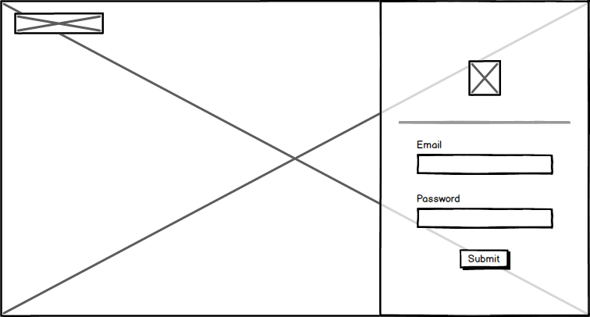

**Admin Page**

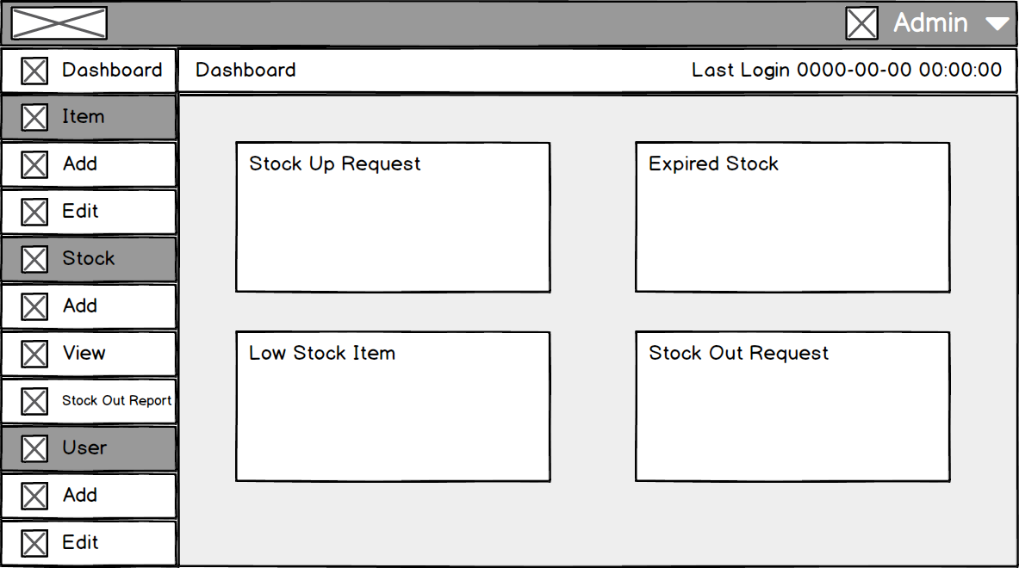

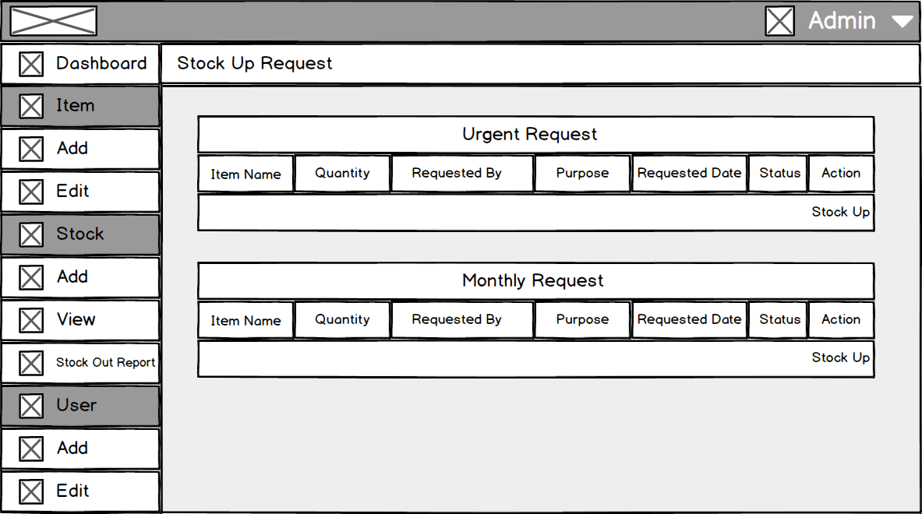

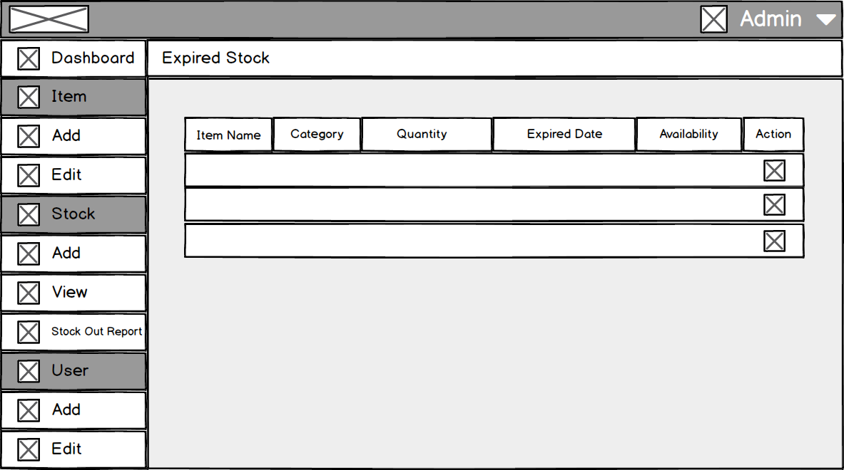

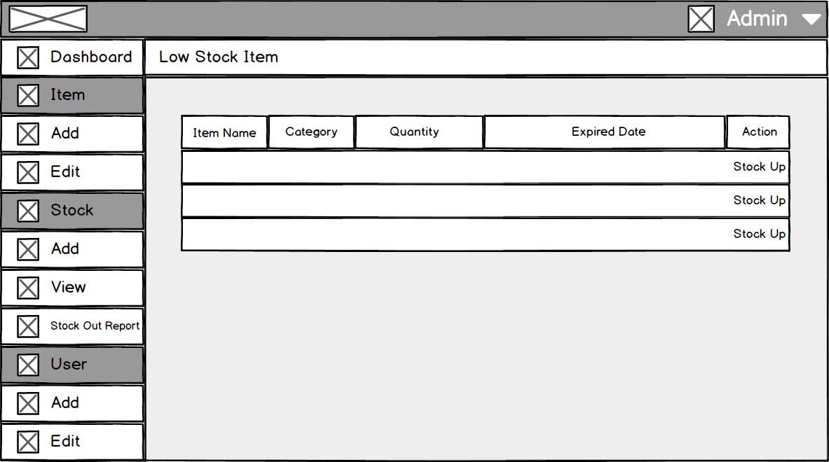

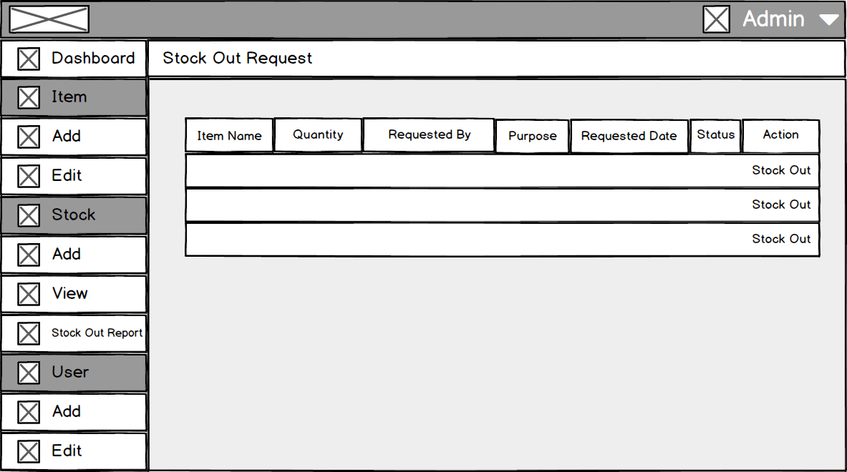

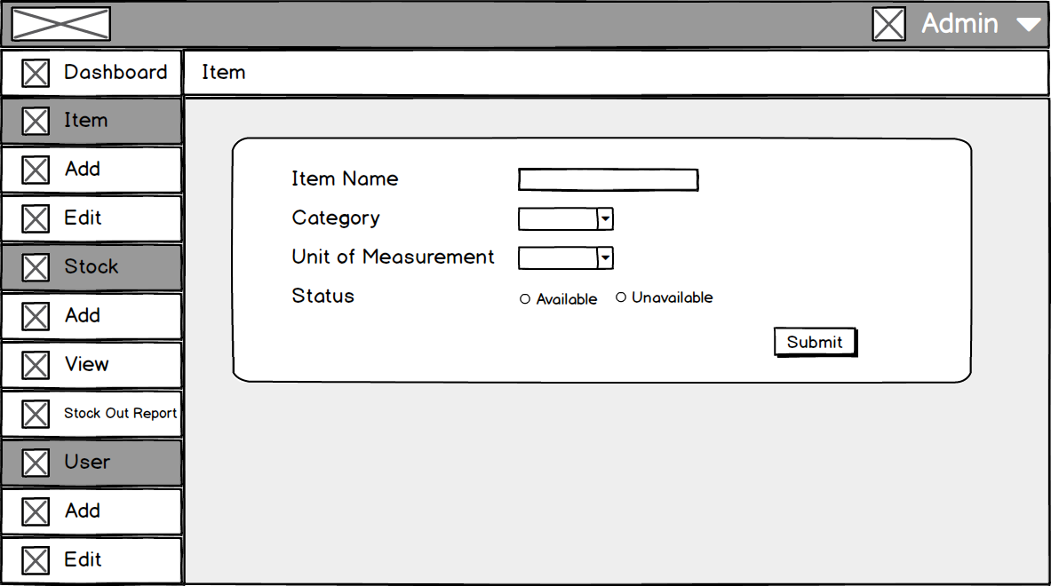 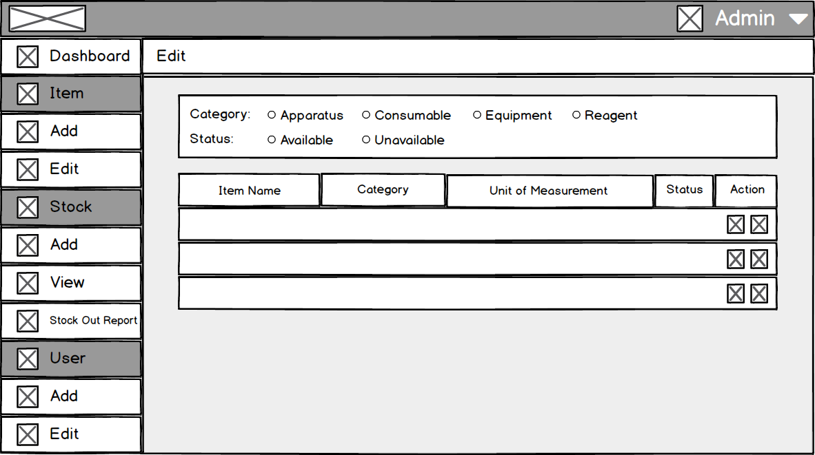 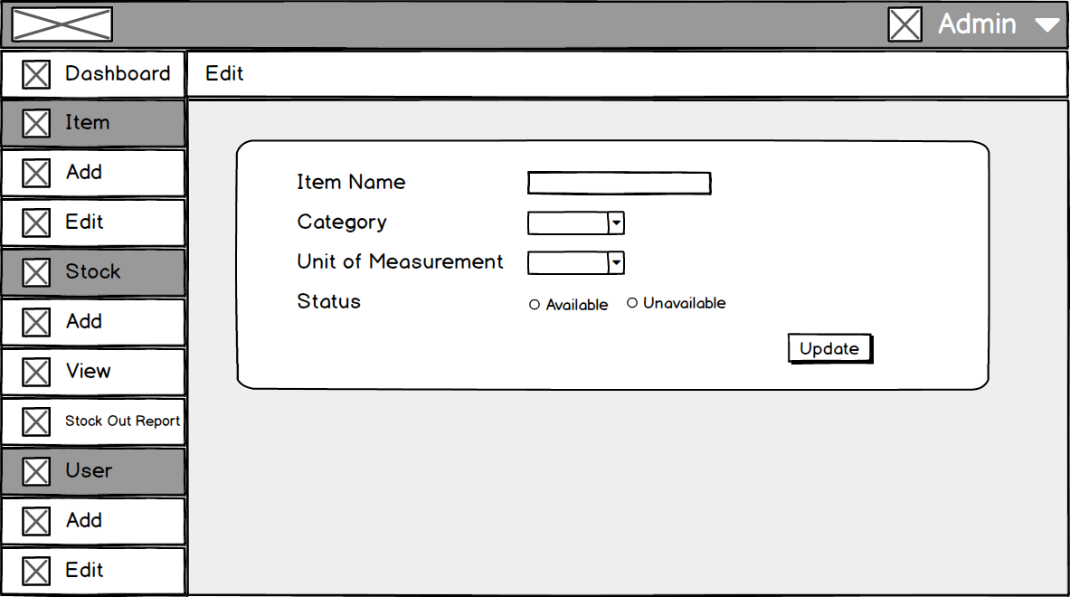

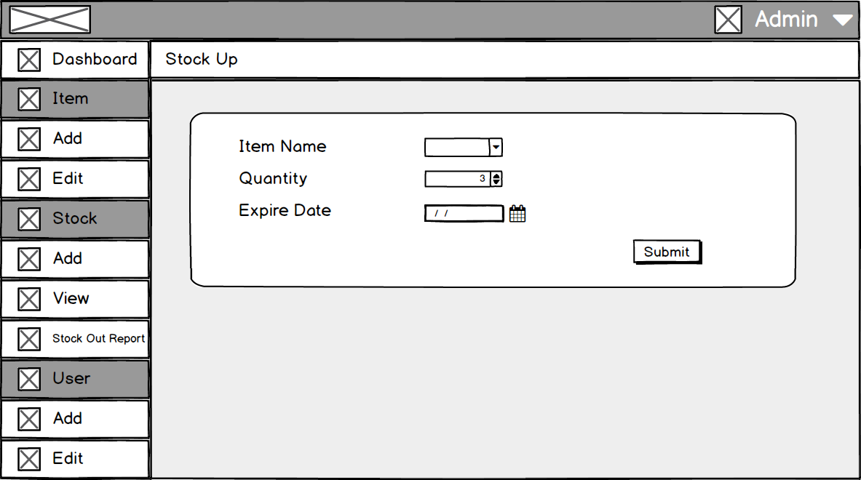

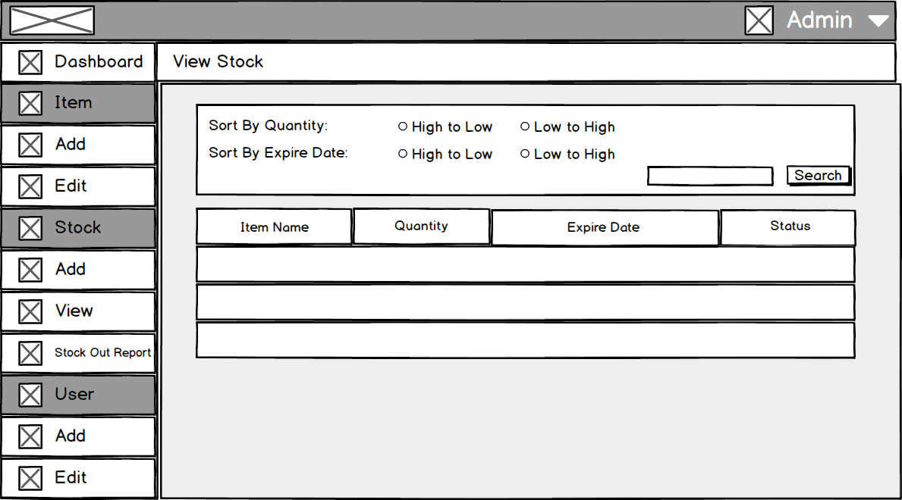

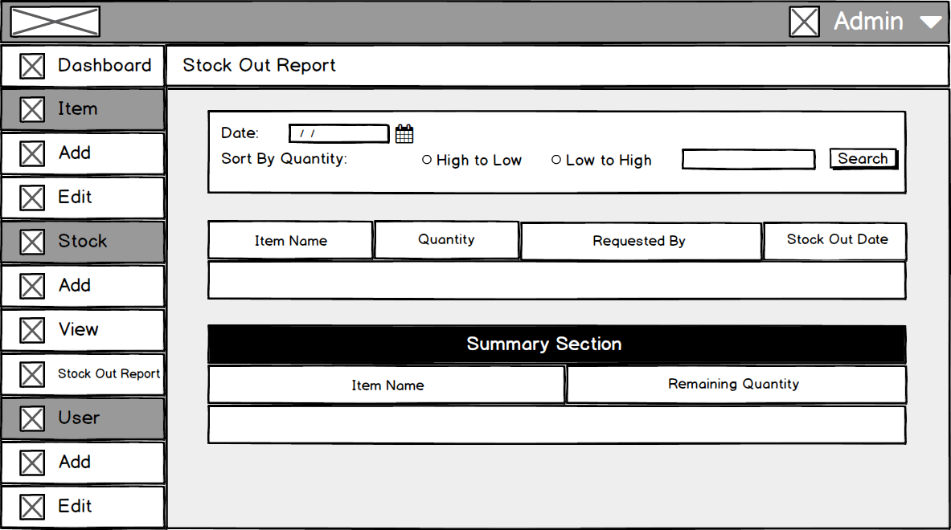

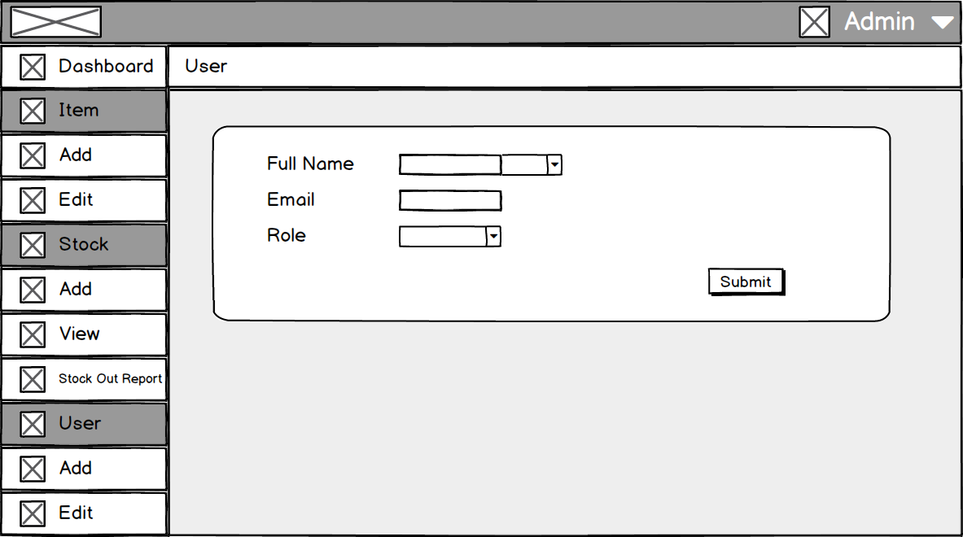

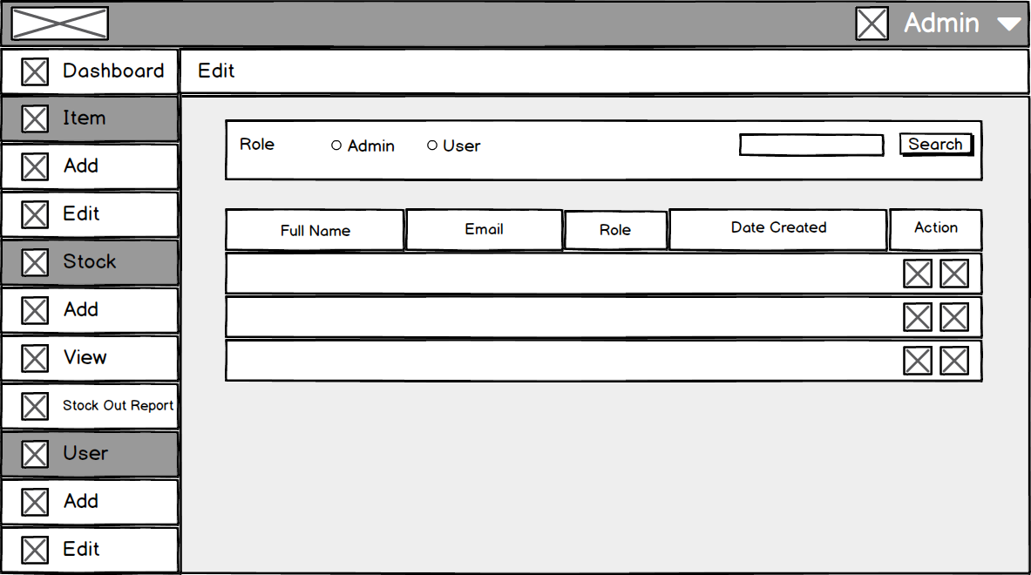

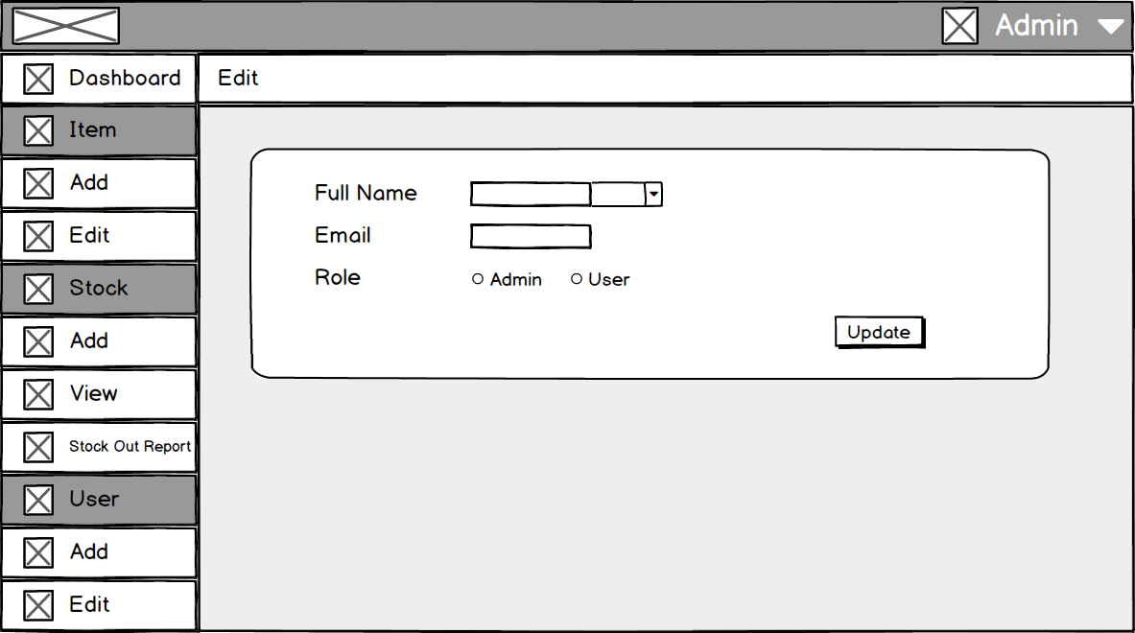

**User Page**

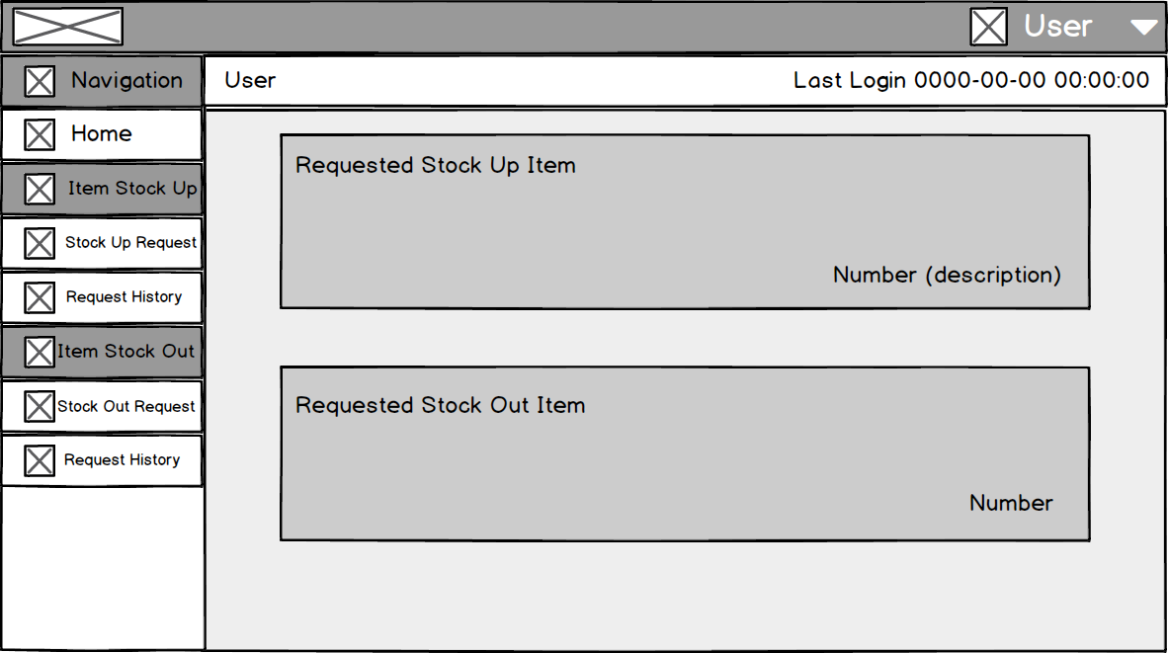

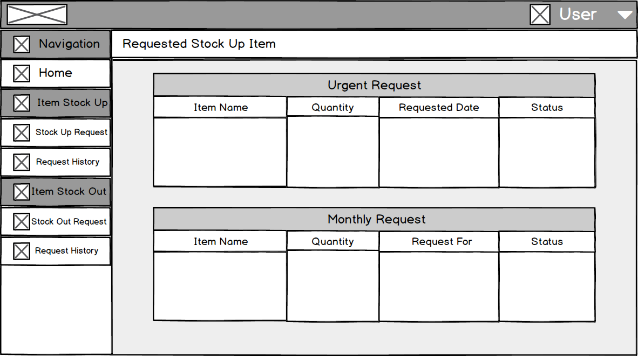

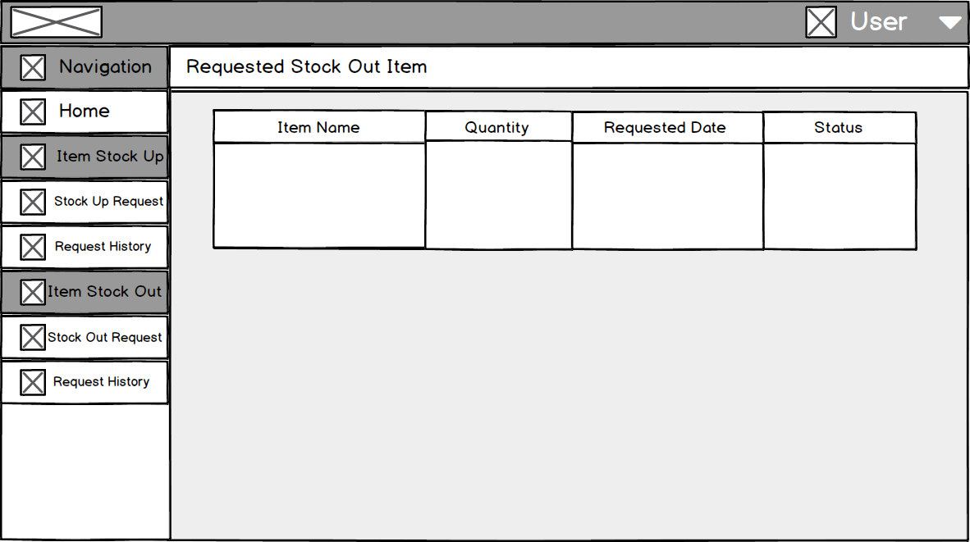

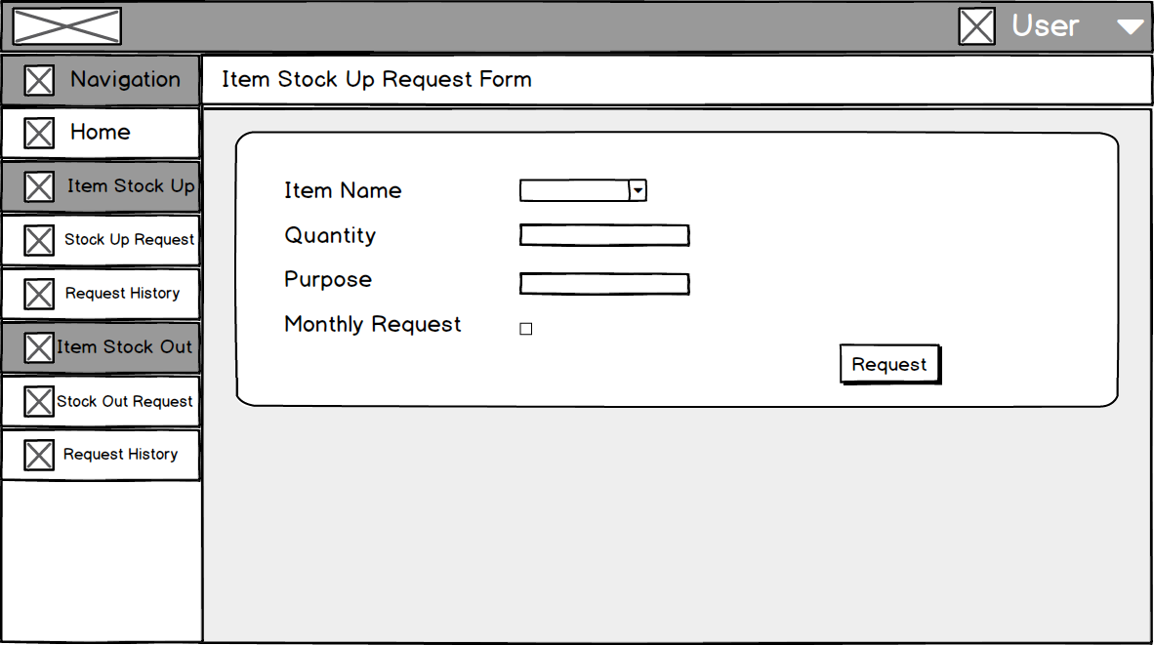

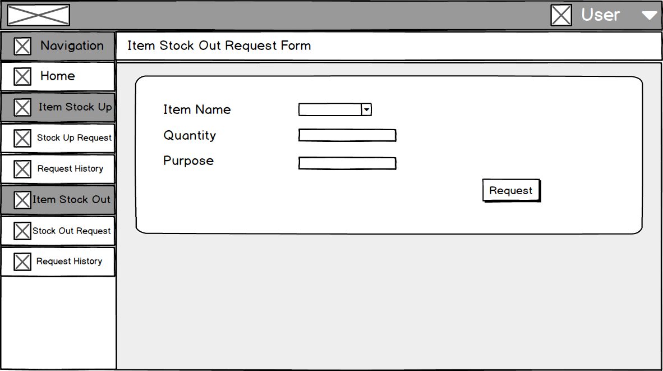

**Manage Account**

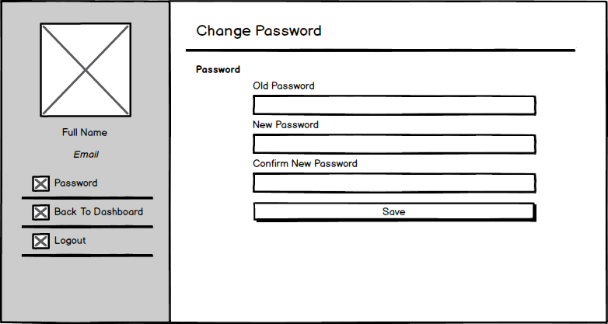

**Interface Design**

**Login Page**

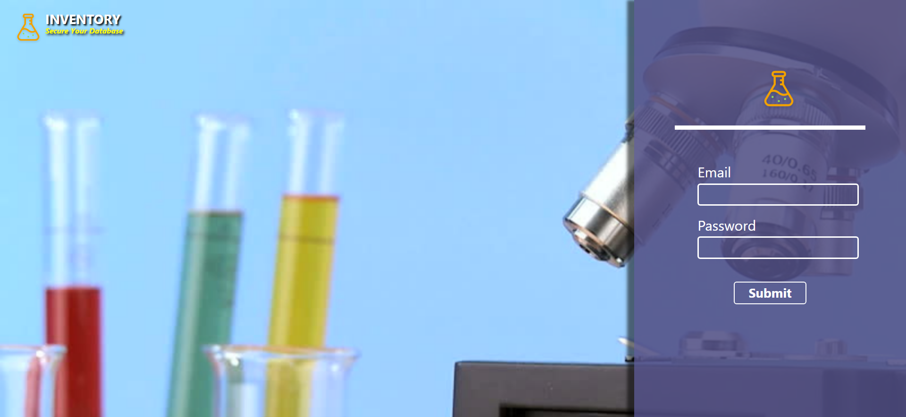

**Admin Page**

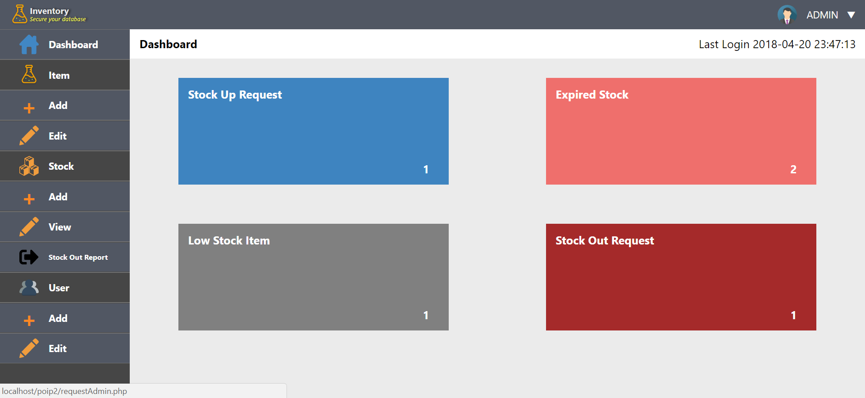

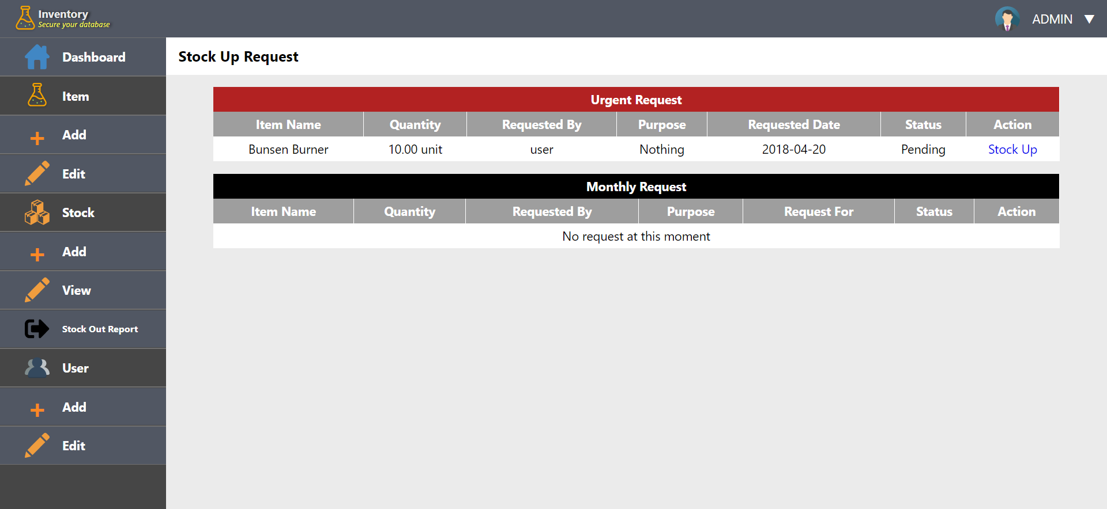

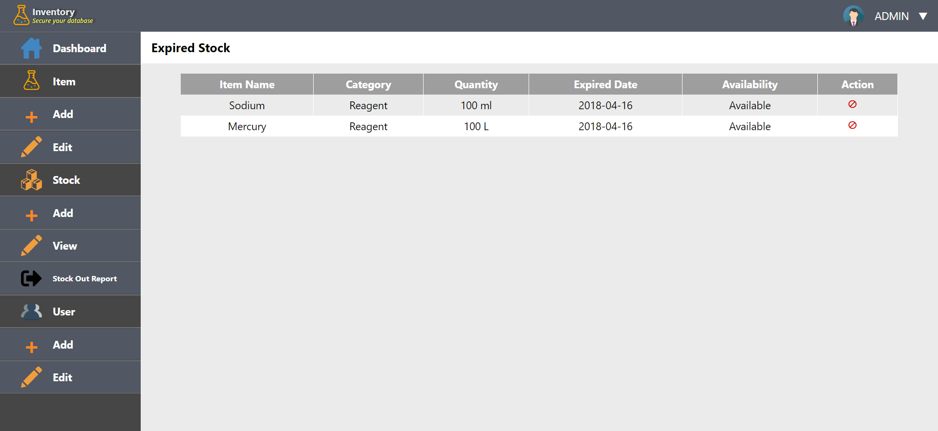

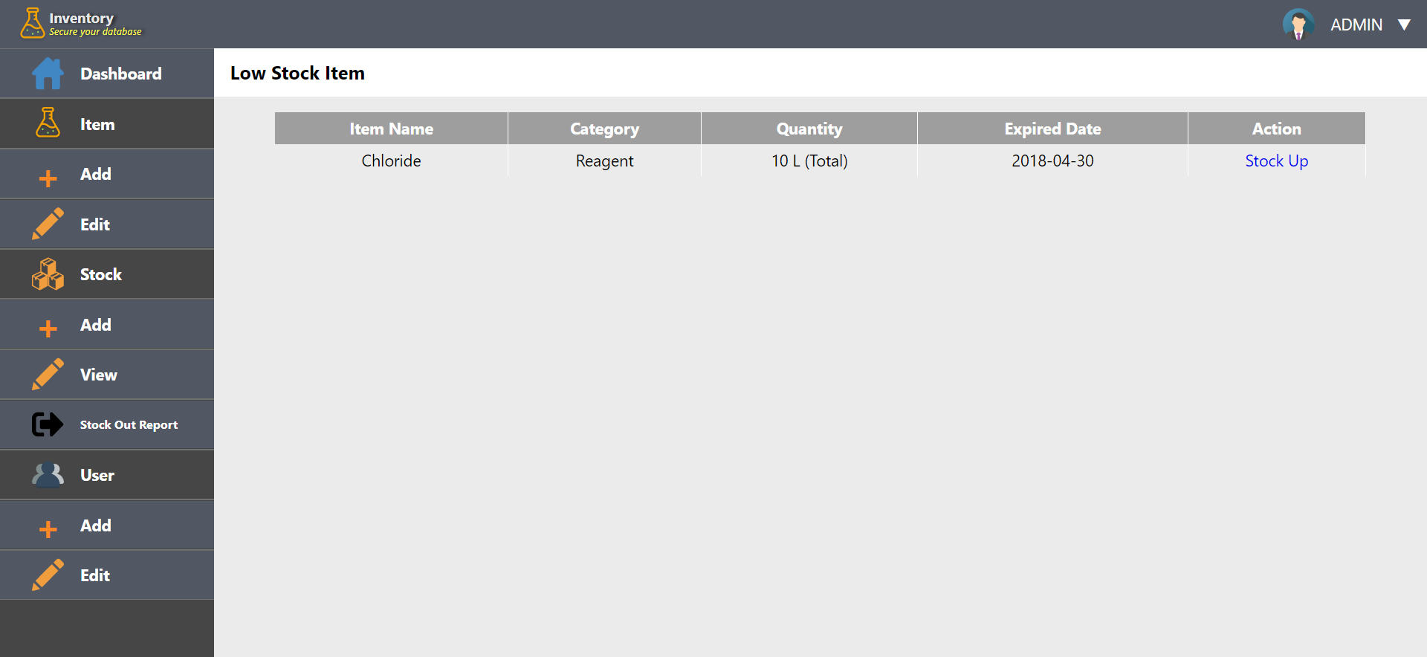

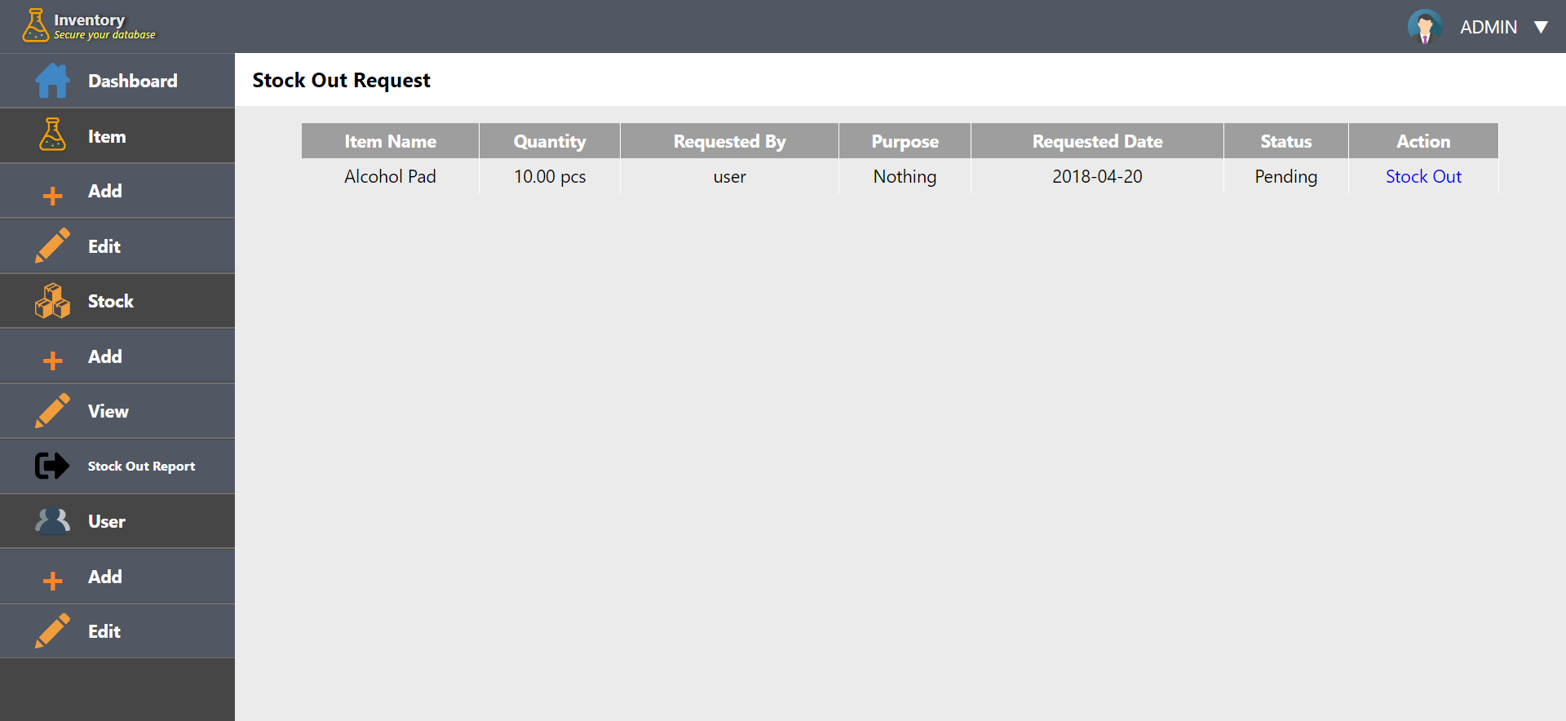

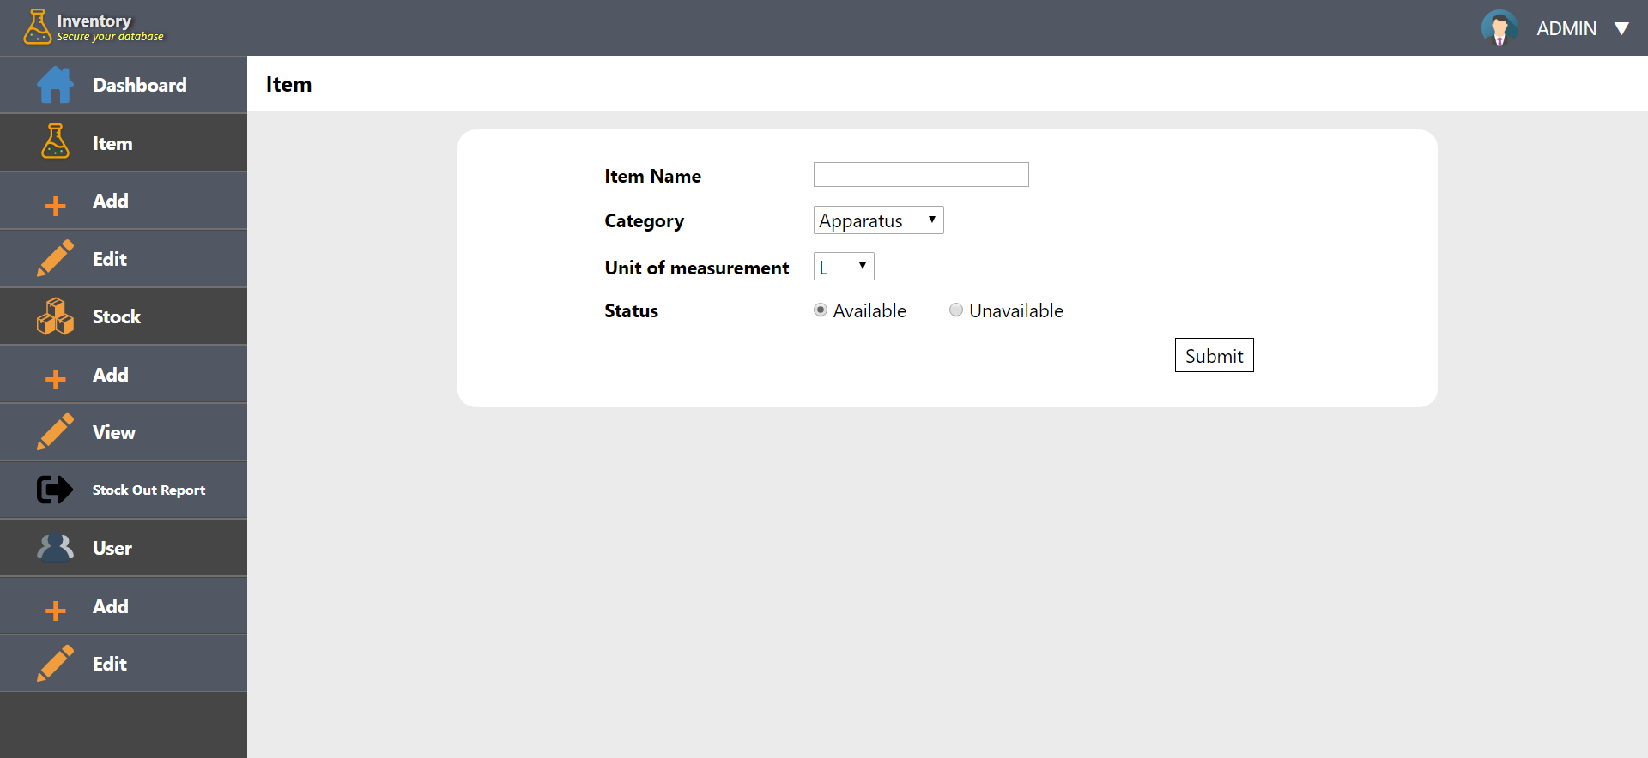

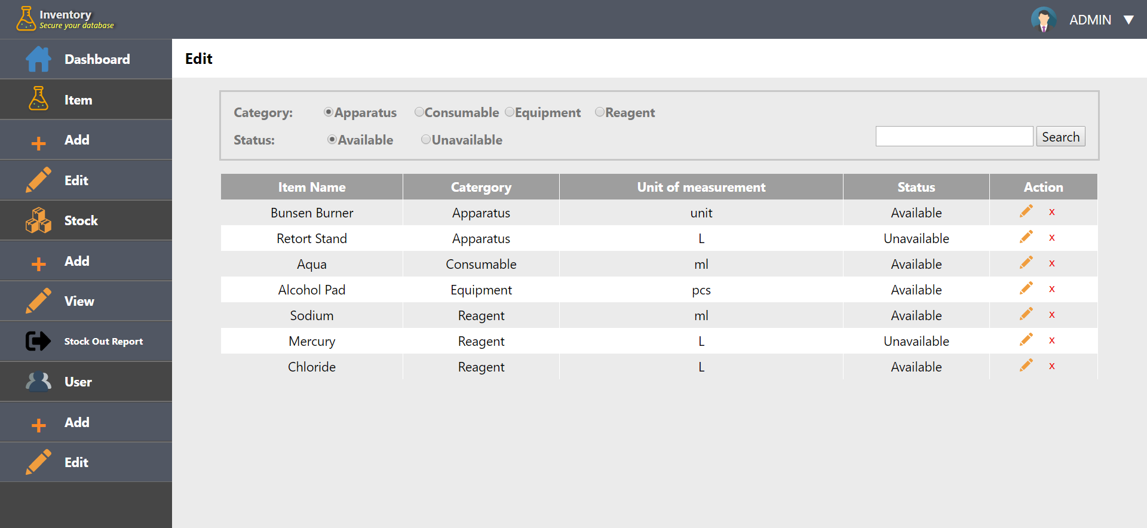

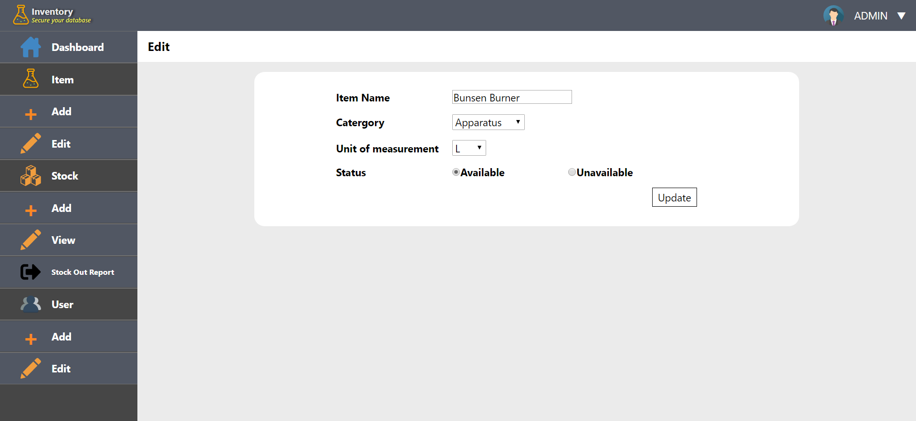

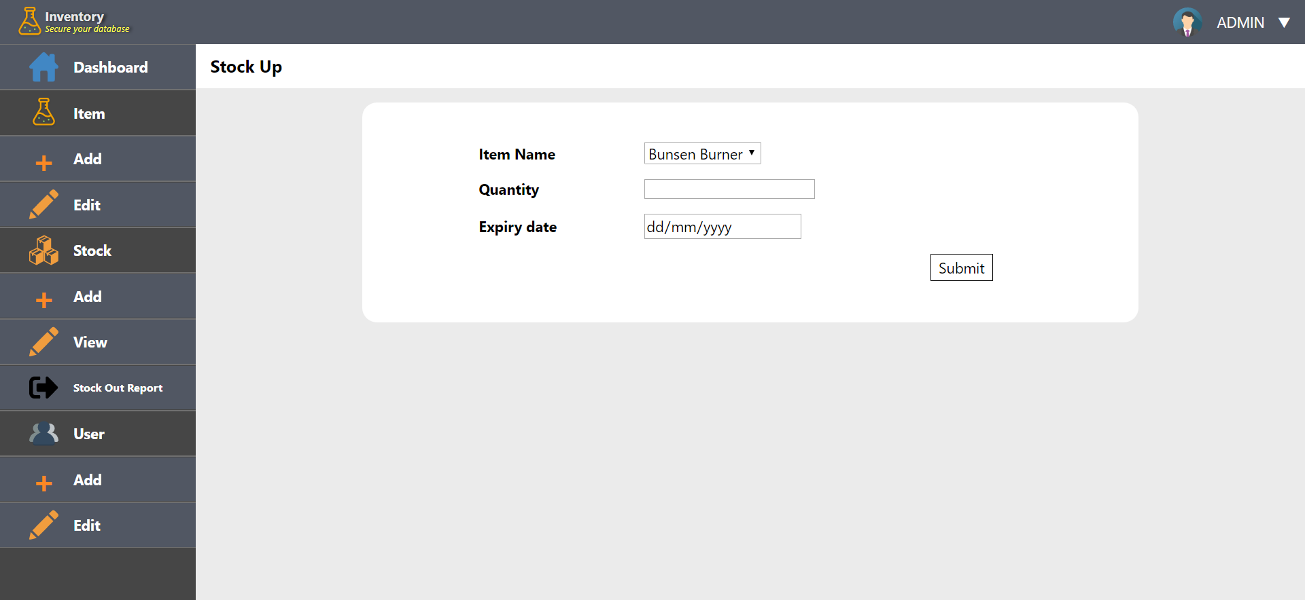

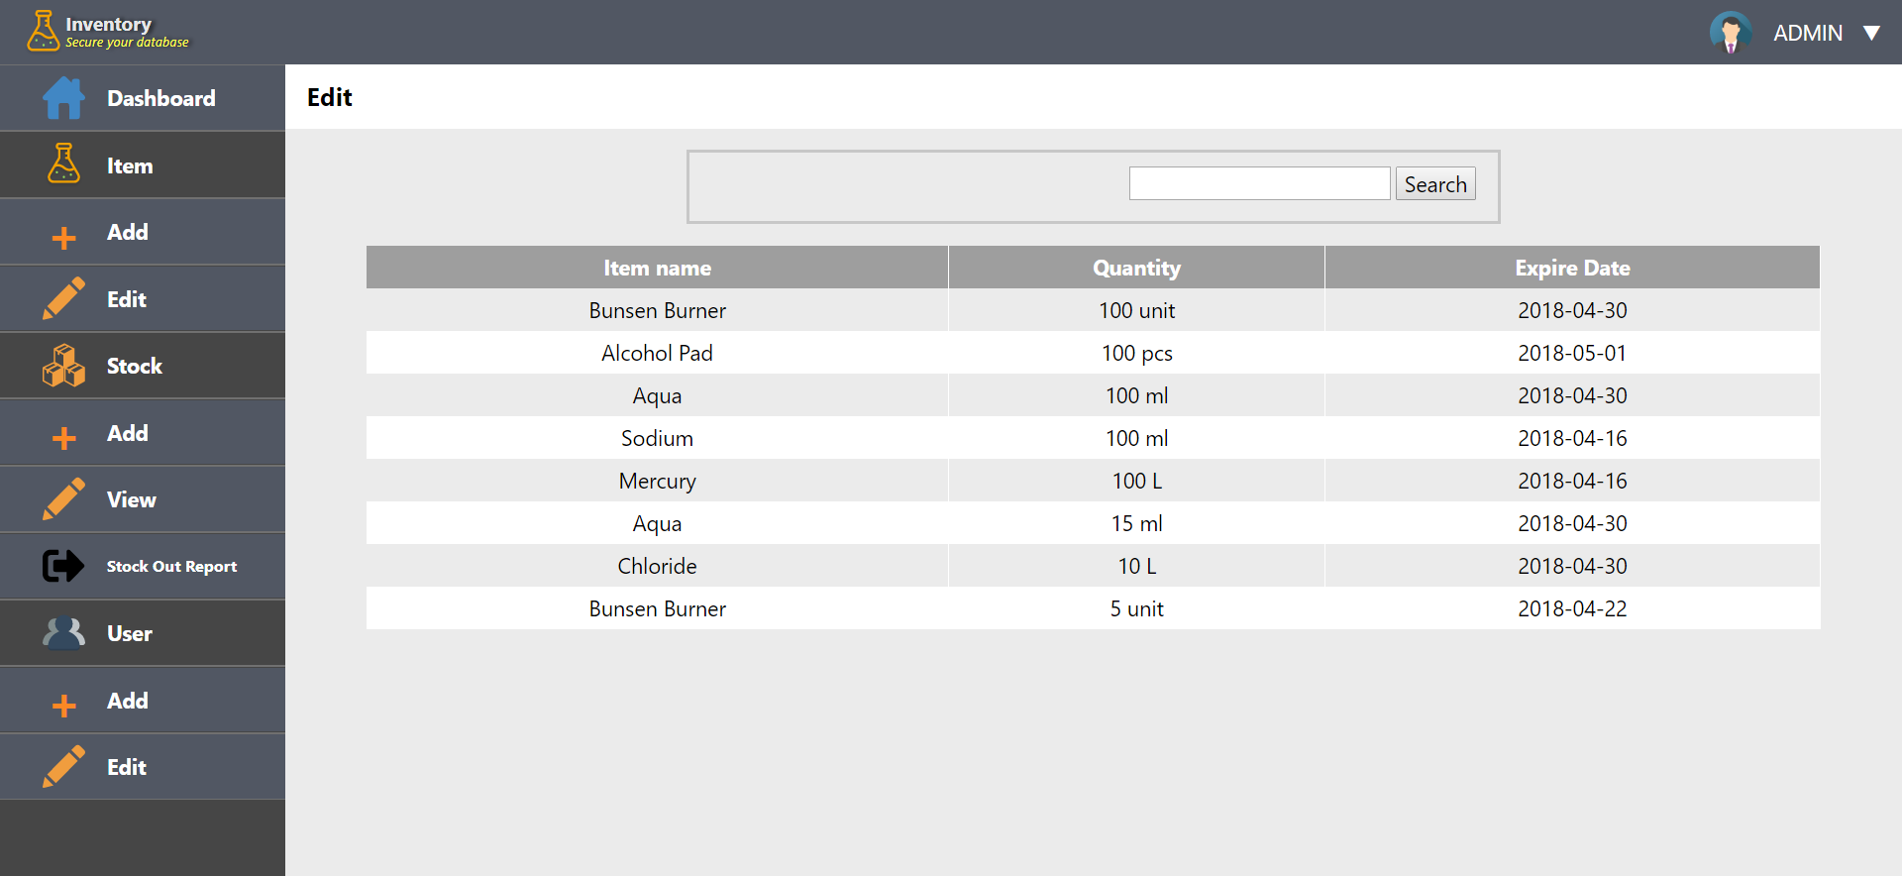

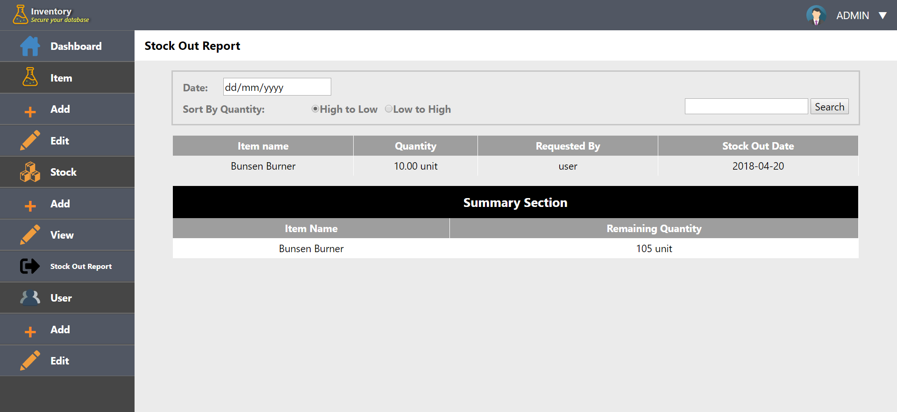

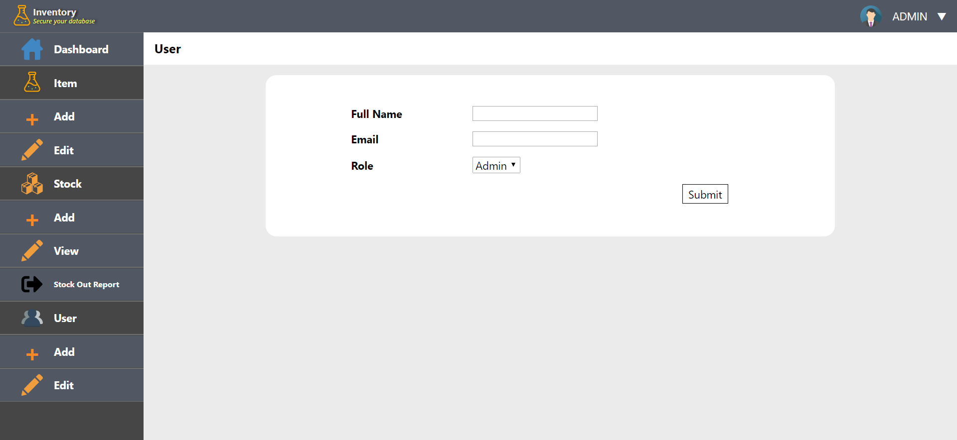

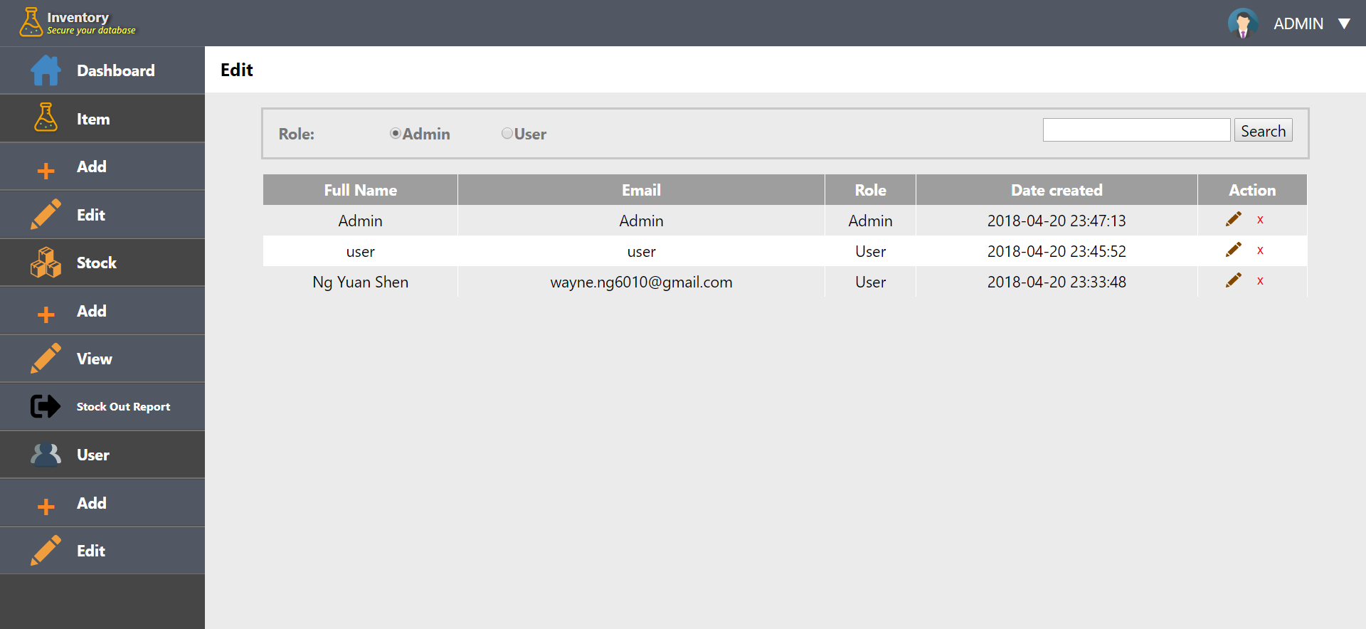

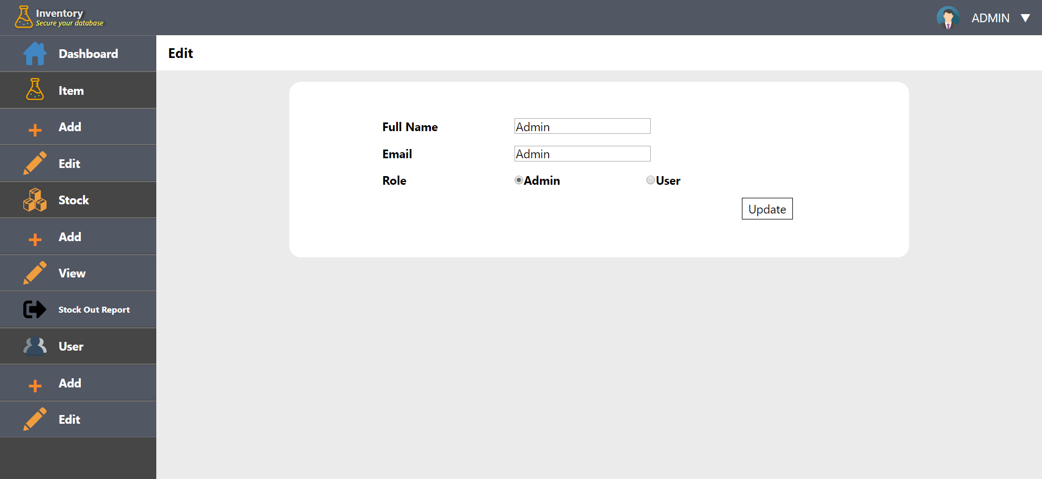

**User Page**

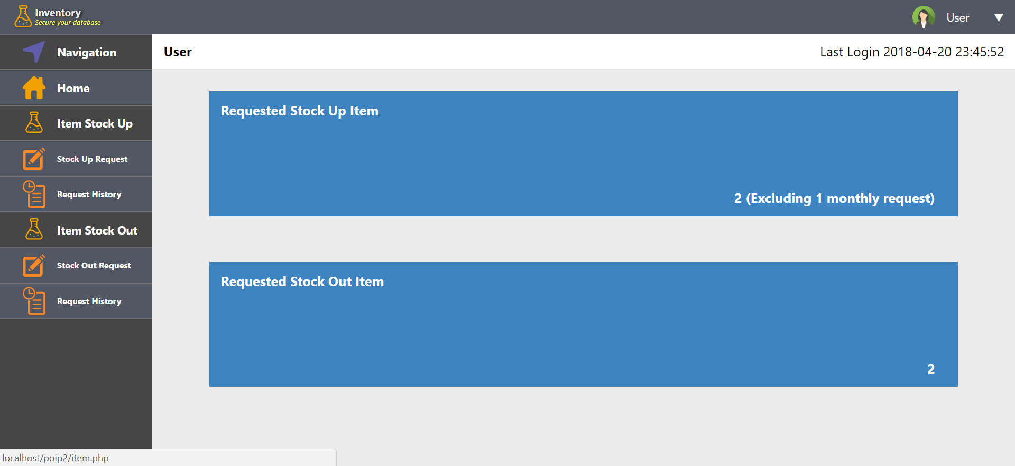

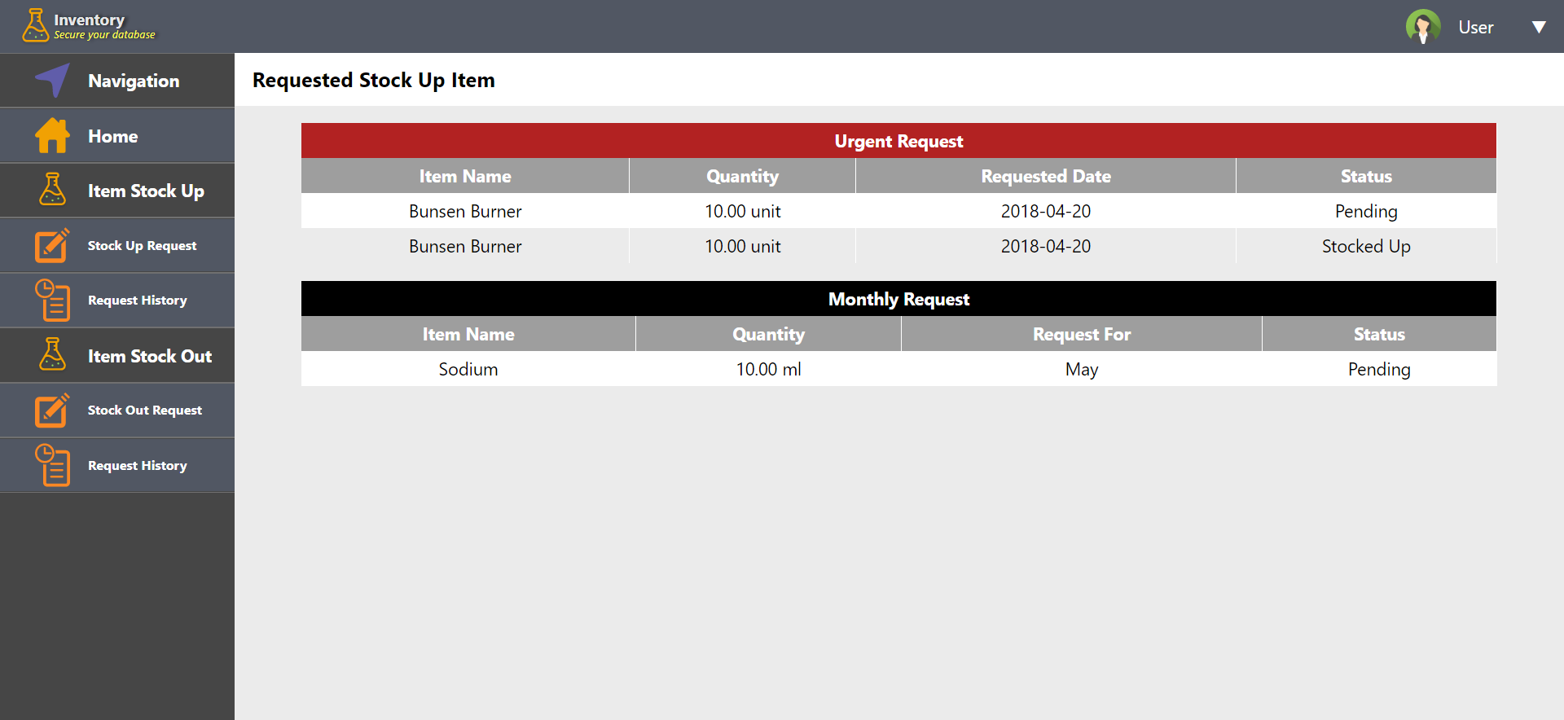

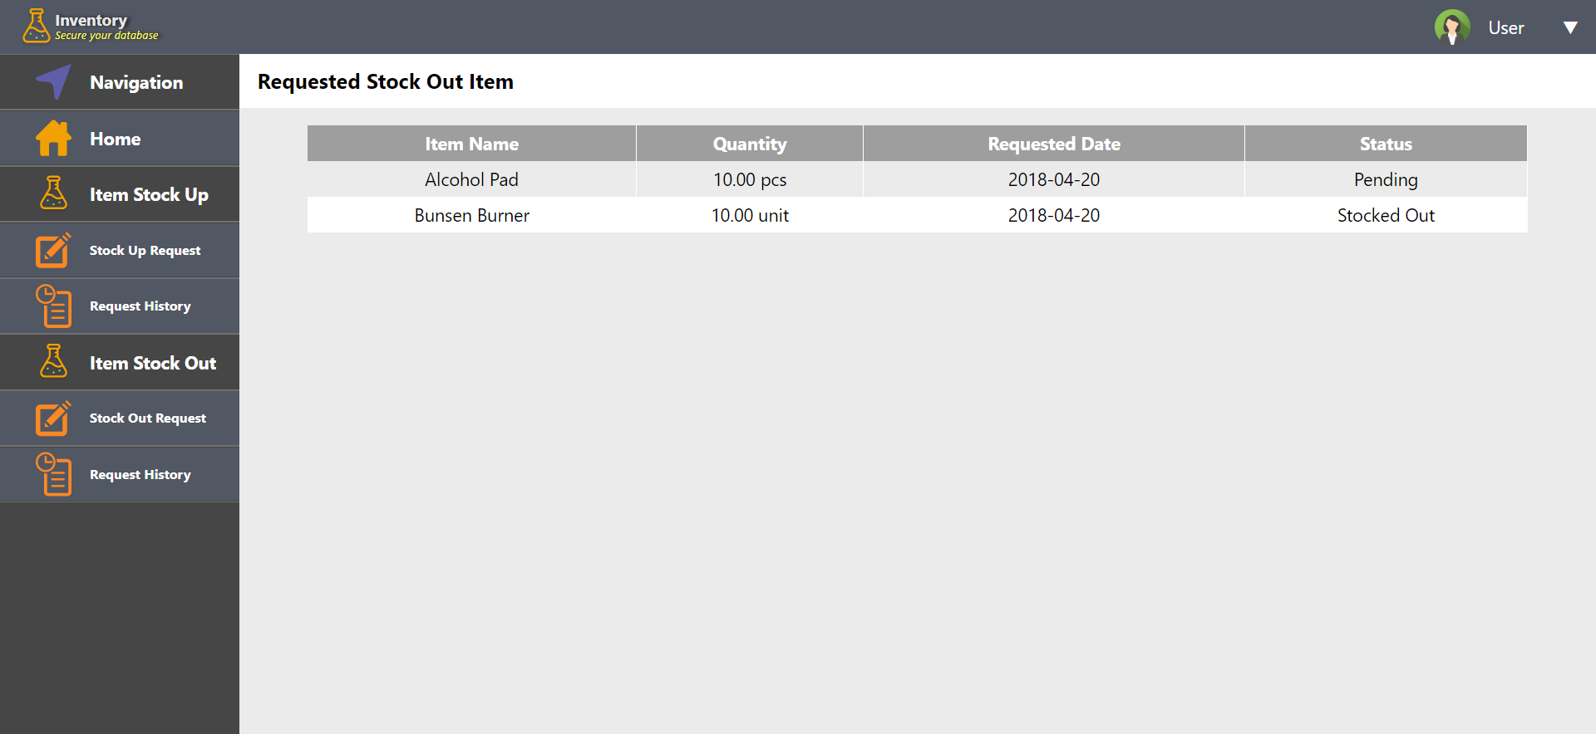

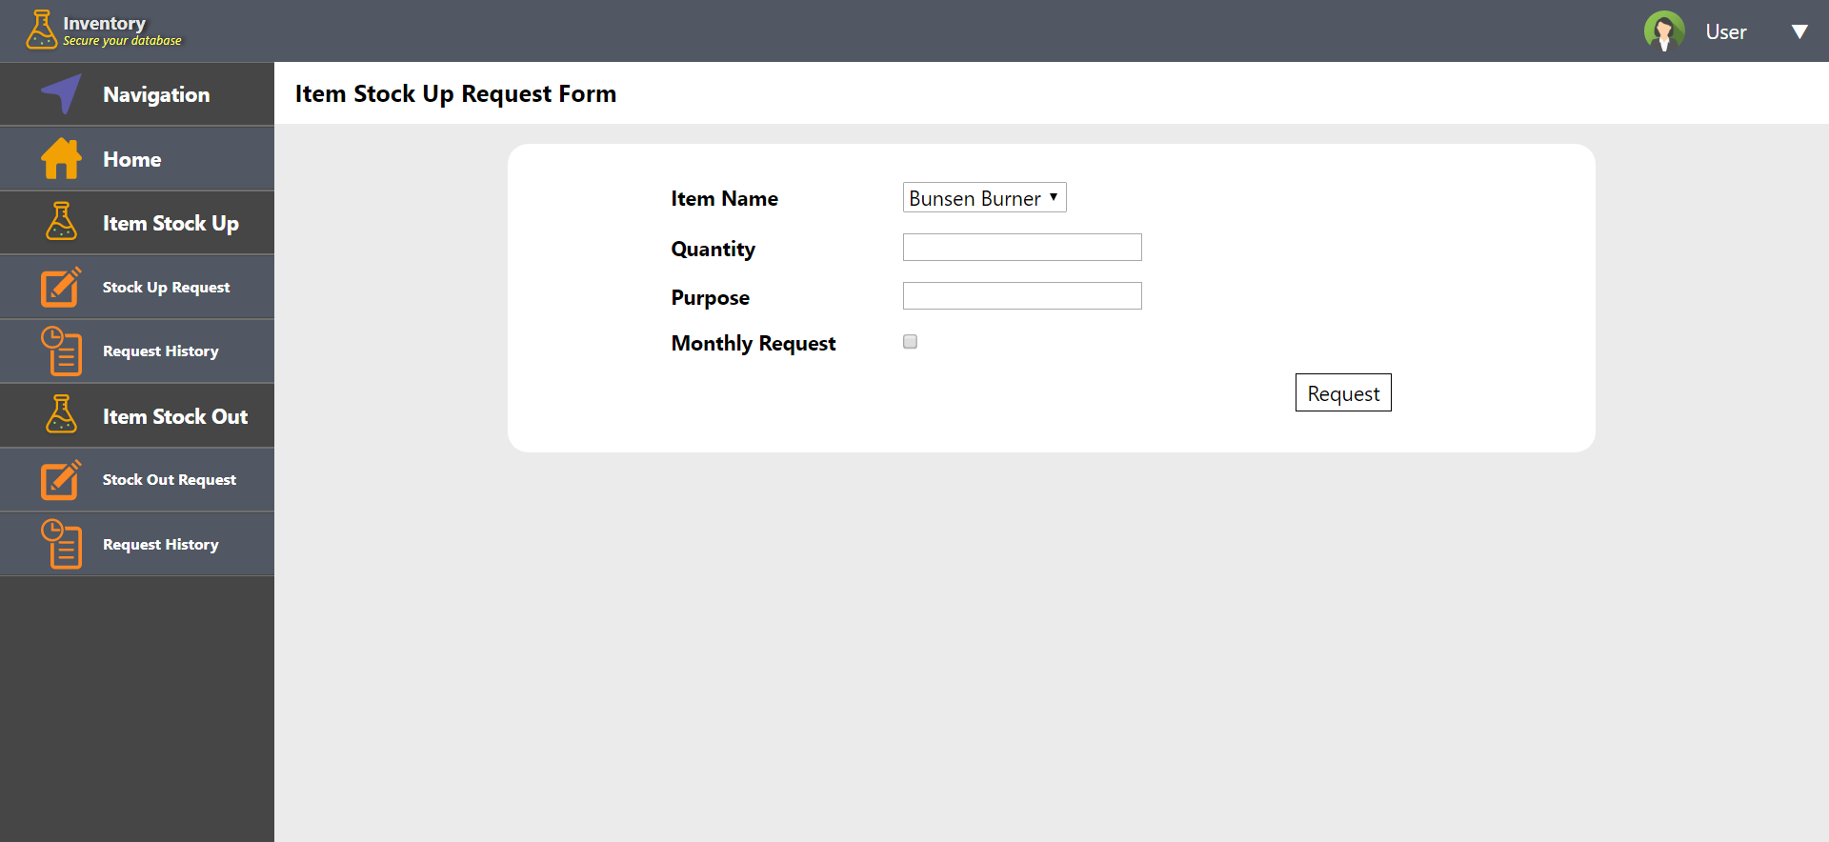

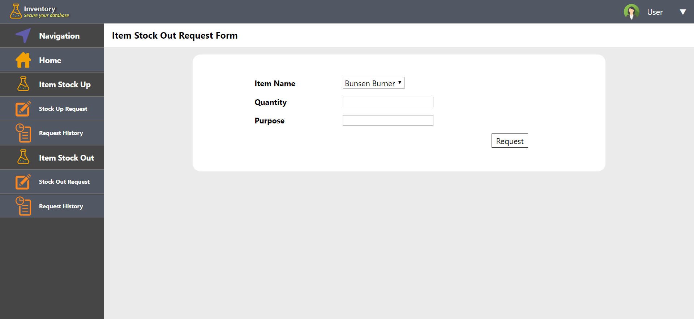

**Manage Account**

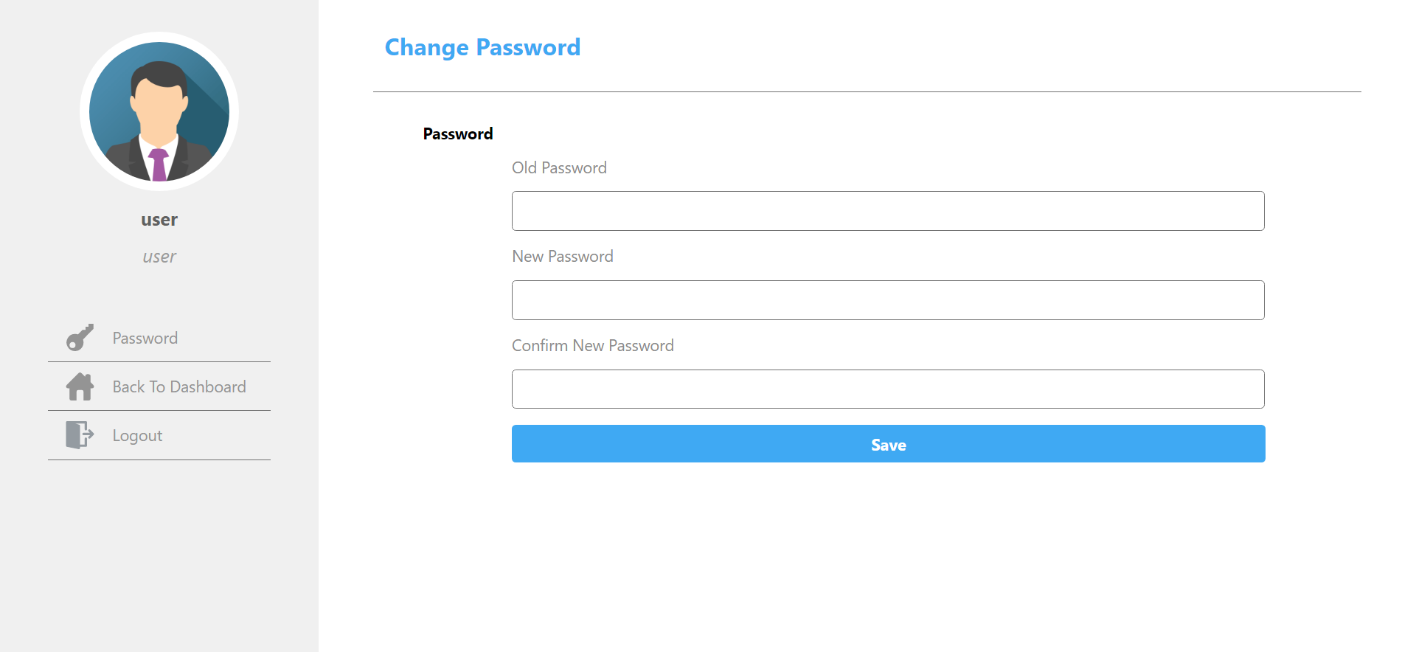

**Database Design**

**Table: category**



**Table: Item**

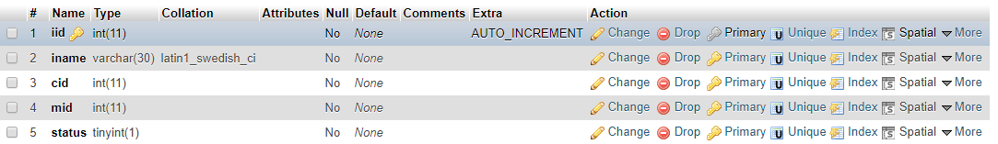

**Table: measure**



**Table: Request**

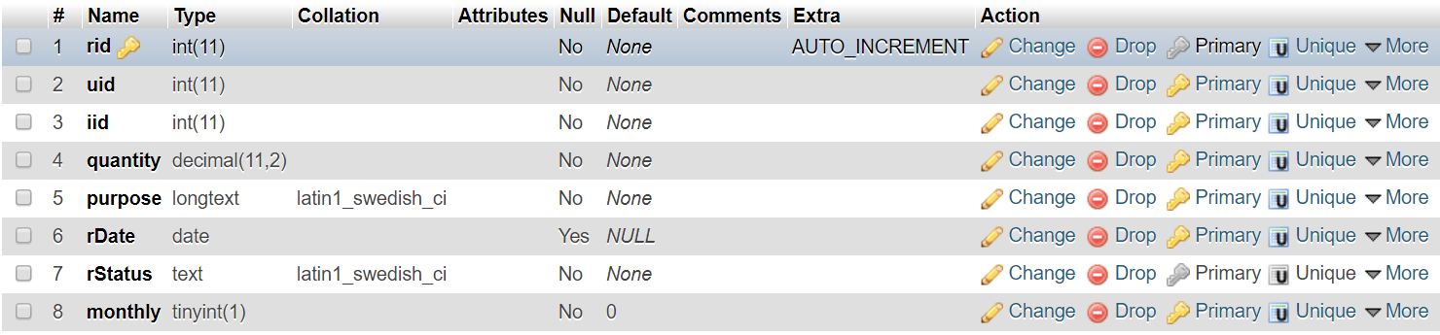

**Table:** [**requestsout**](http://localhost/phpmyadmin/sql.php?db=poip2&table=requestsout)

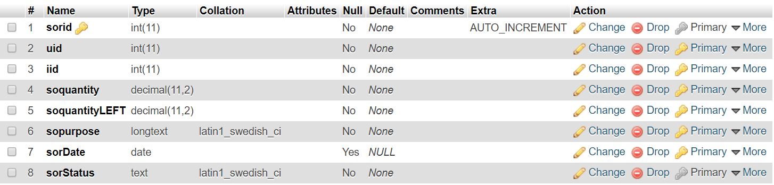

**Table: soreport**

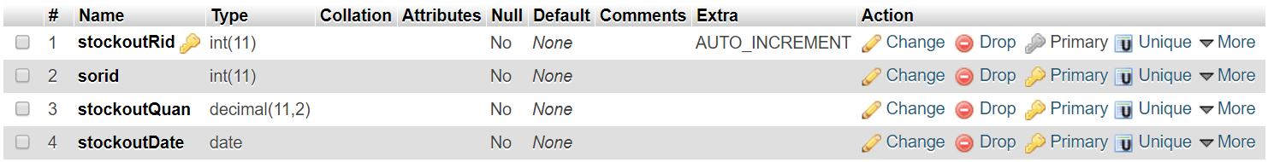

**Table: Stock**

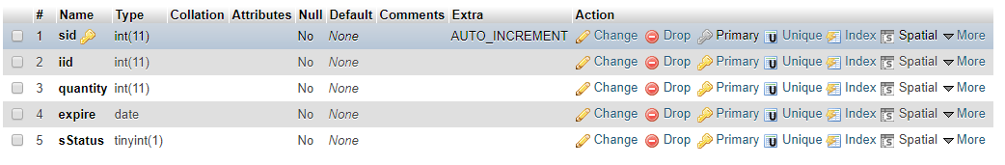

**Table: user**

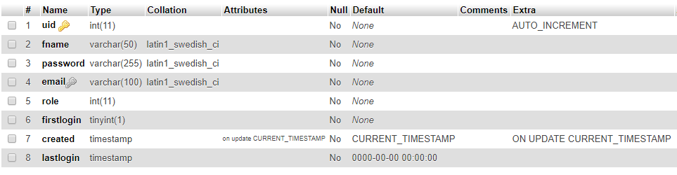

**Screenshots of Outputs (Admin Page)**

**Receiving Notification**

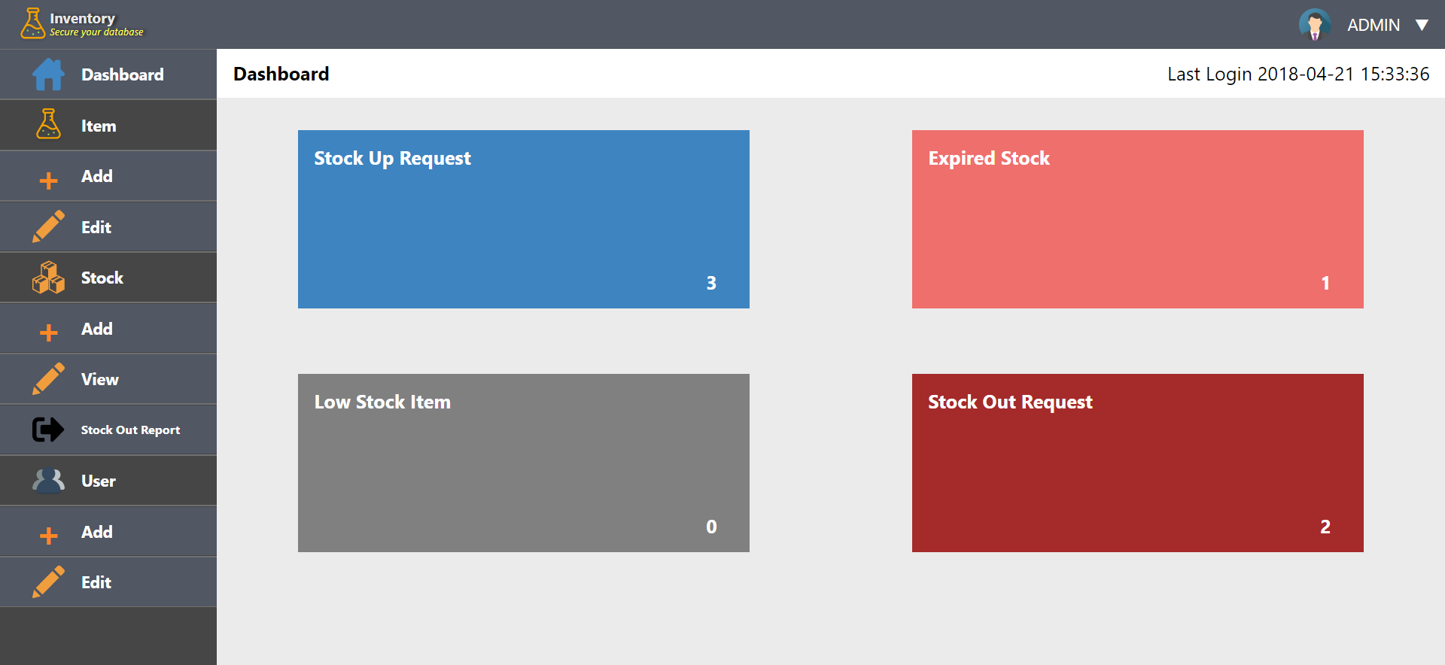

**Changing availability of expired stock to unavailable**

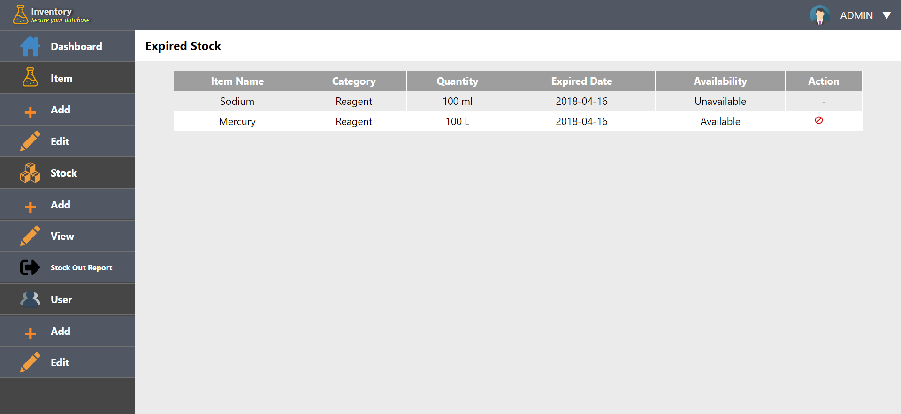

When clicking on red circle icon, admin will be prompted

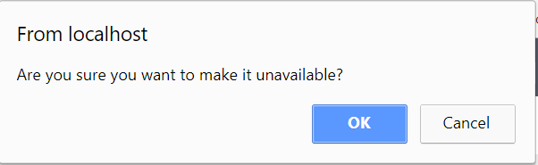

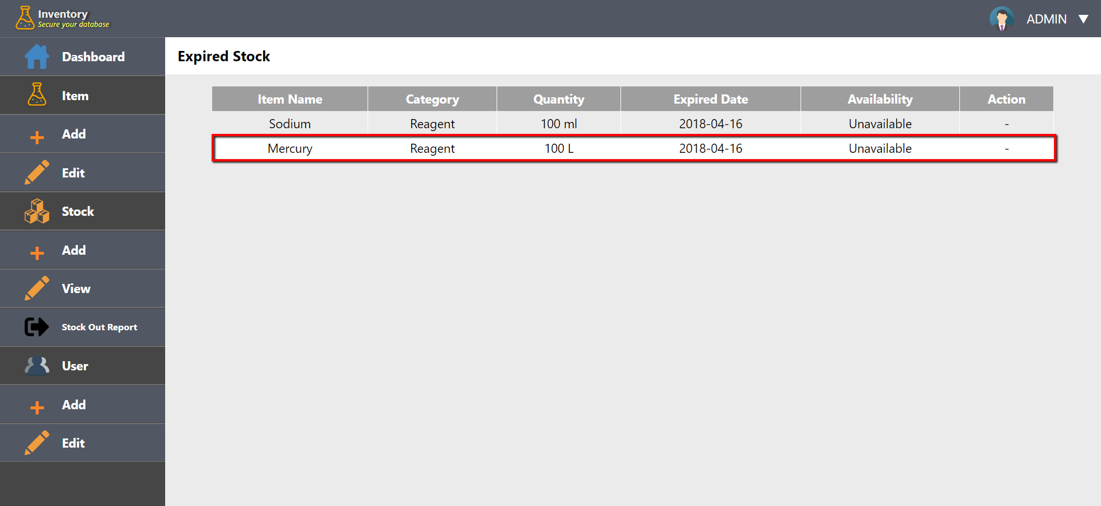

**Viewing Stock Out Report**

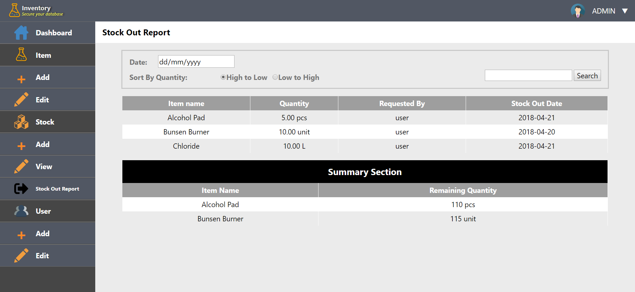

**Adding Item**

***Input***

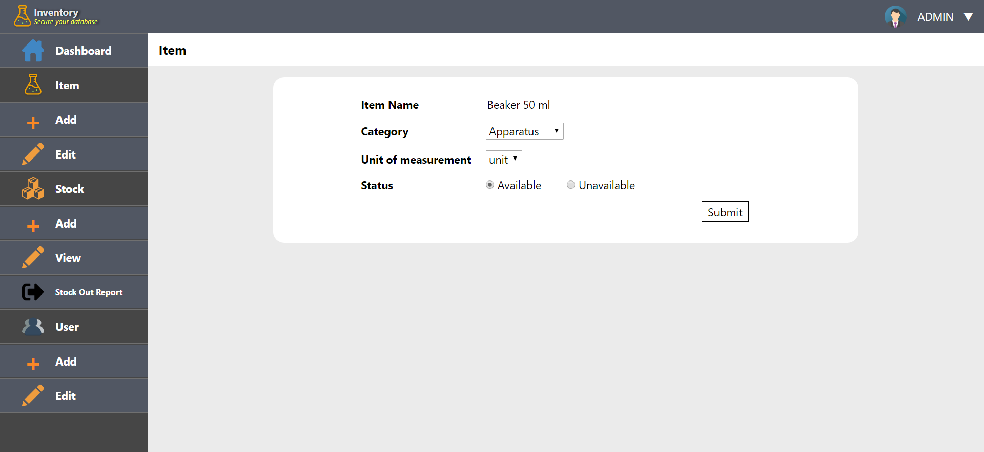

***Output***

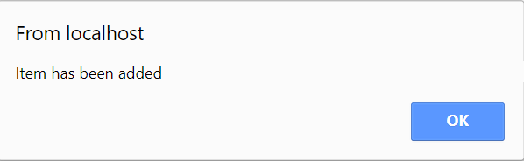

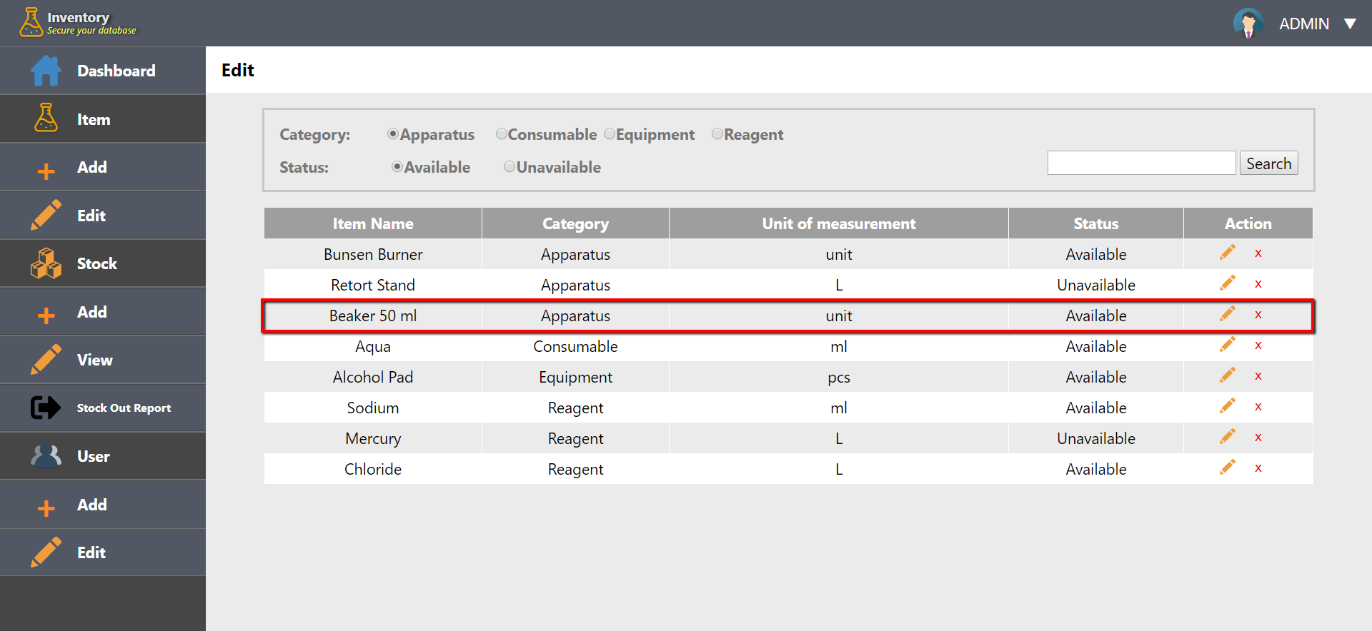

**Editing Item**

***Input***

Changing from “Beaker 50 ml” to “Beaker 10 ml” and from “Available” to “Unavailable”

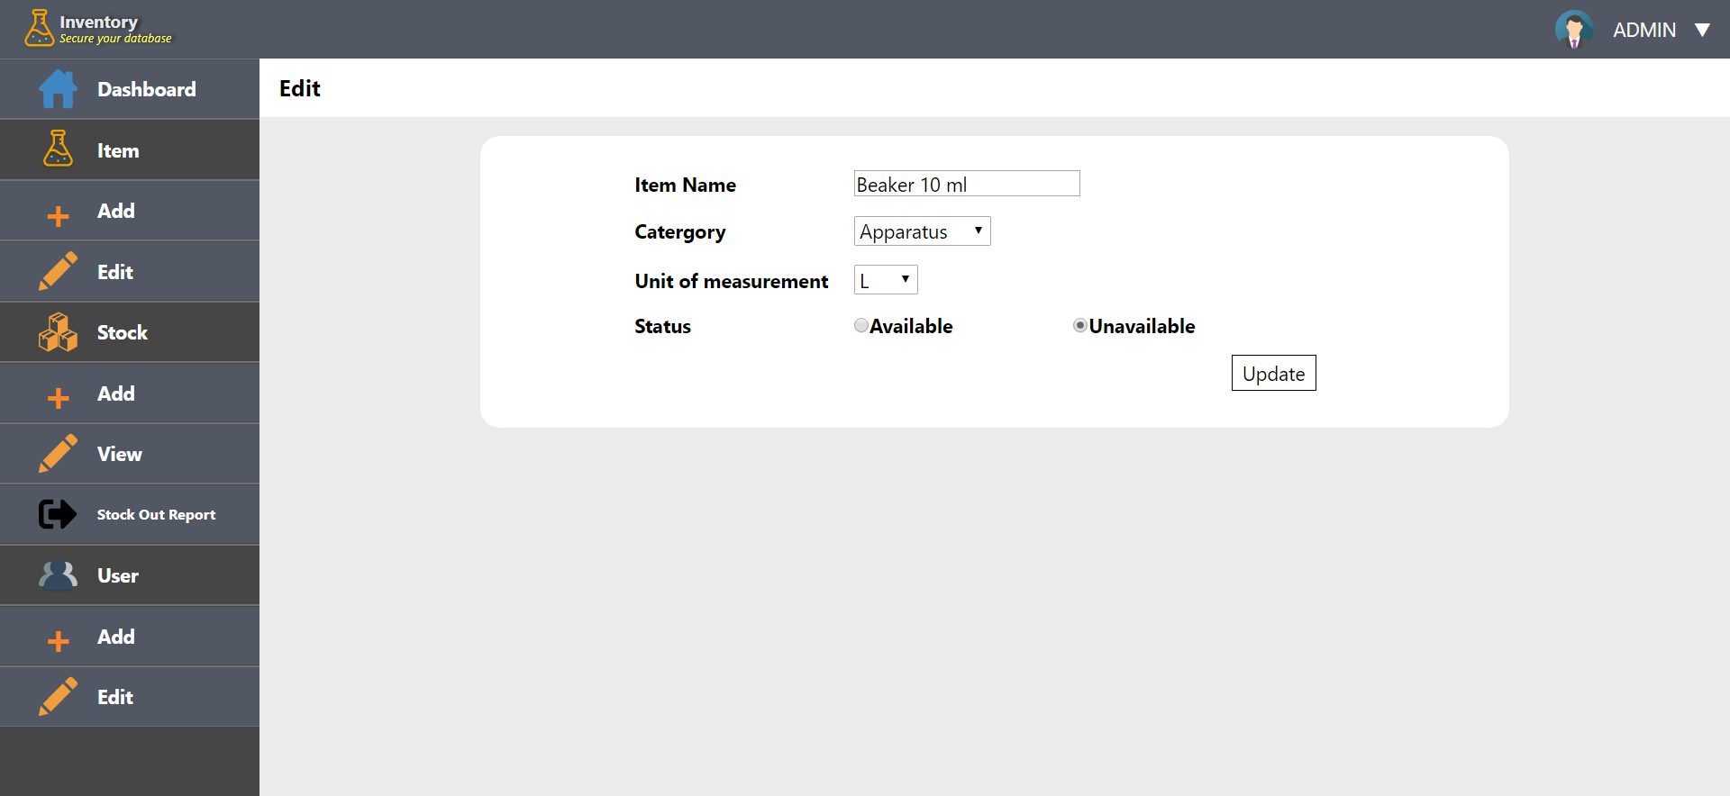

***Output***

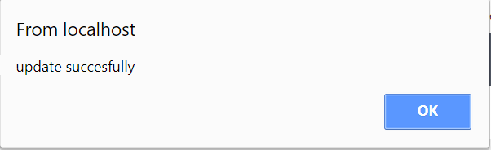

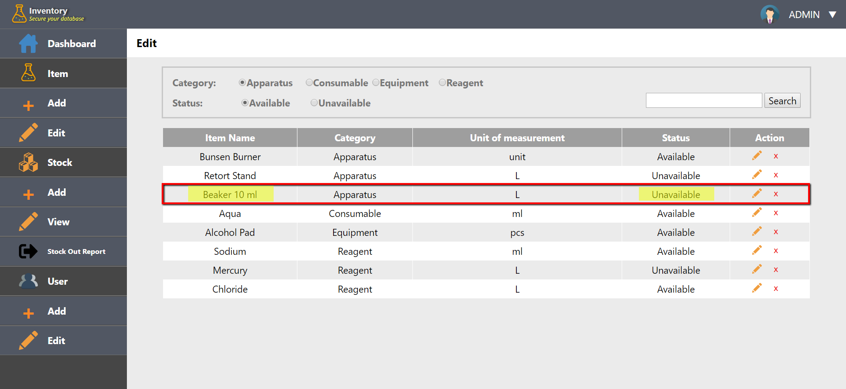

**Deleting Item**

When delete icon is clicked (from the item list)

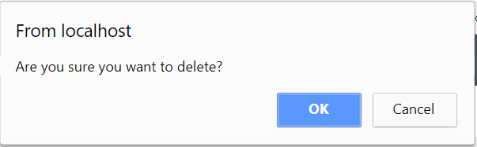

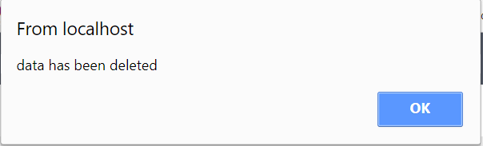

**Stocking Up**

***Input***

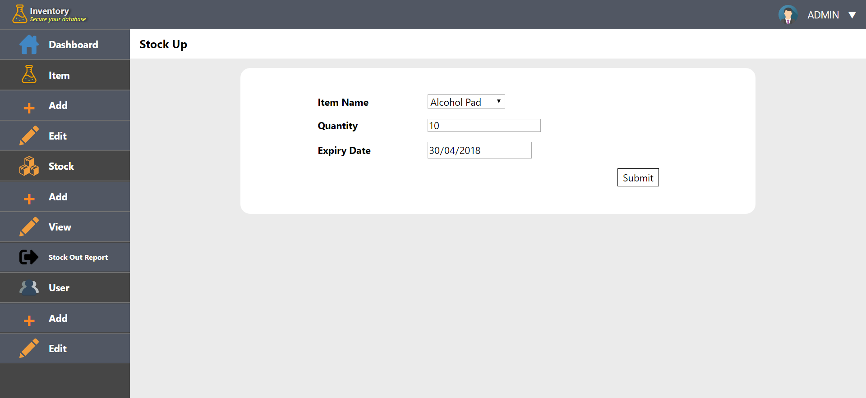

***Output***

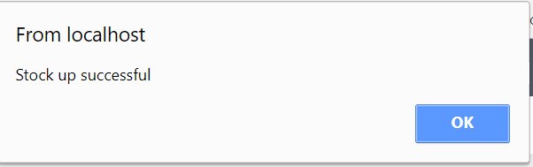

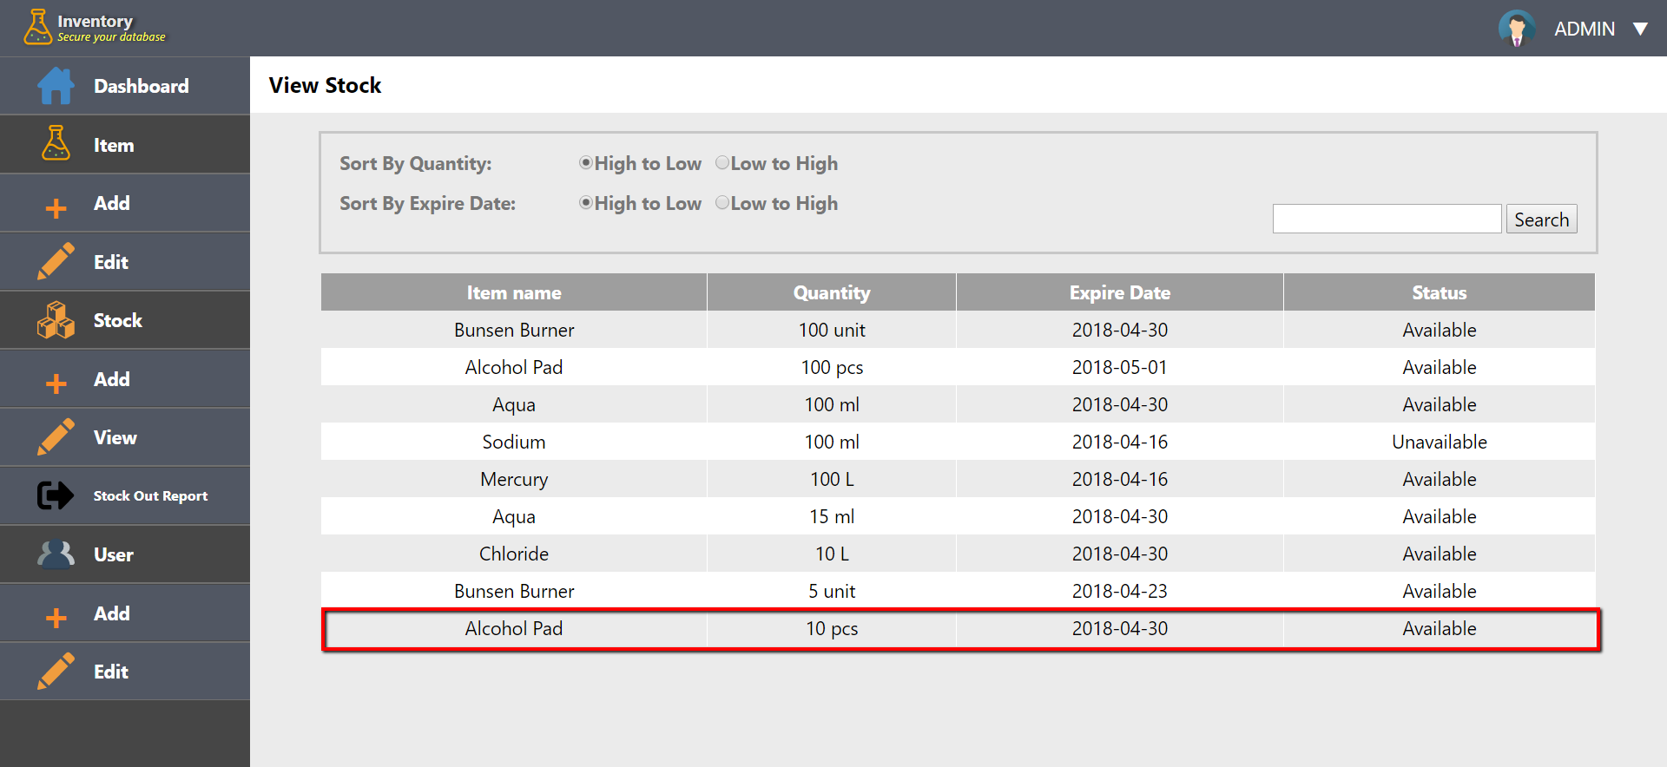

**Stocking Out**

***Input from User Side***

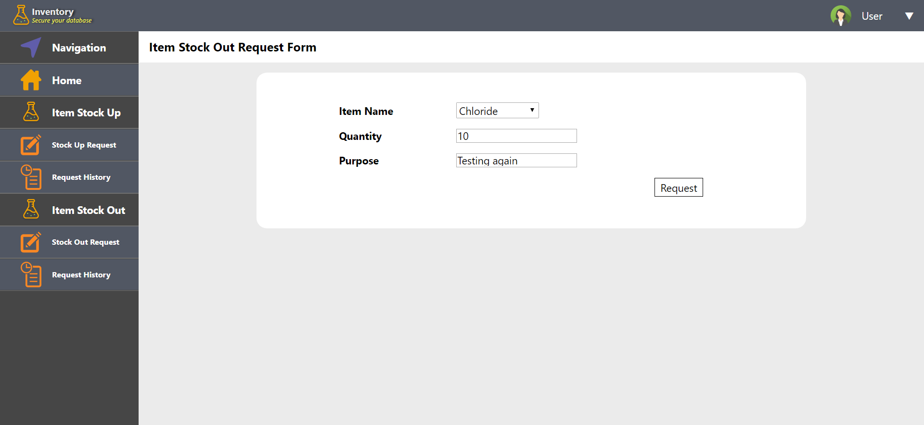

***Output***

Admin Side

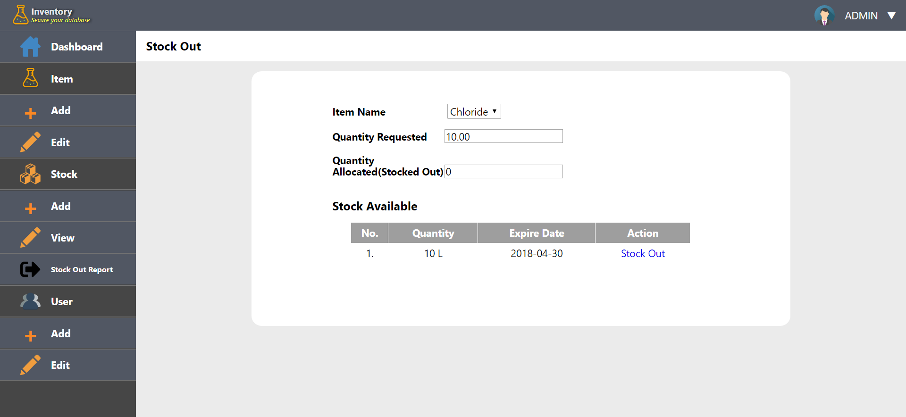

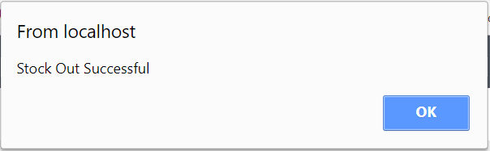

**Sorting Result**

***Input***

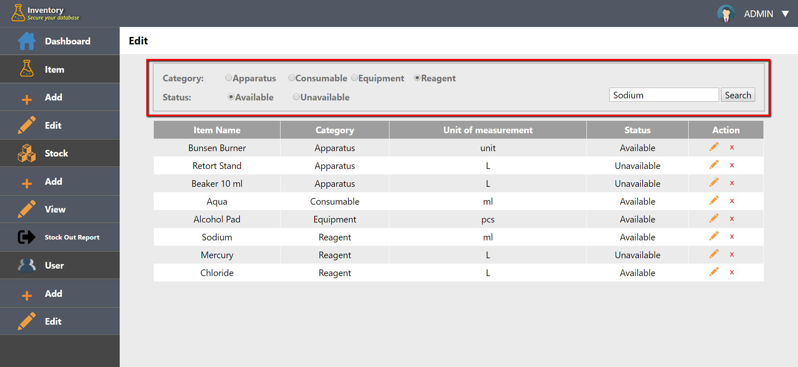

***Output***

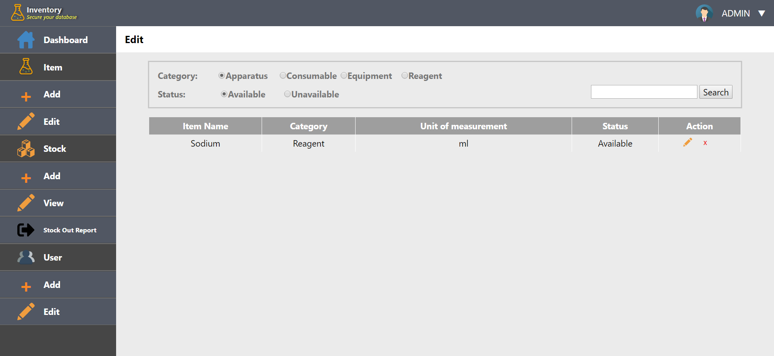

**Adding Admin or User**

***Input***

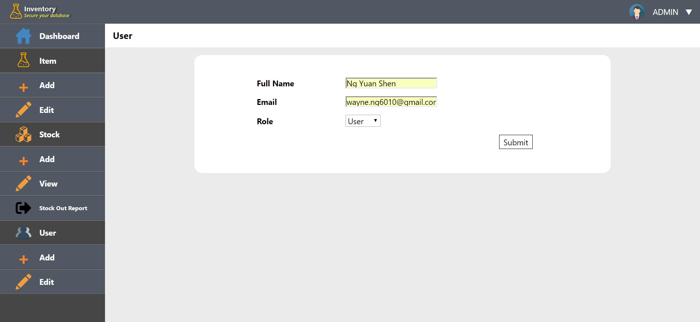

***Output***

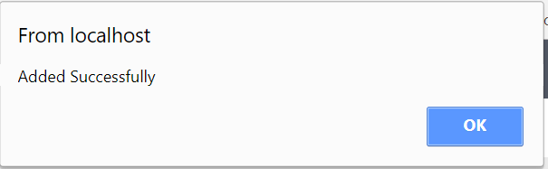

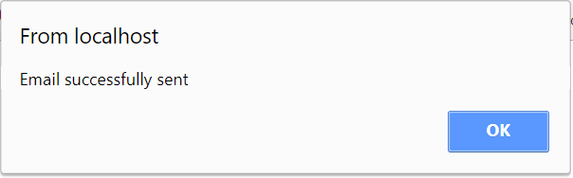

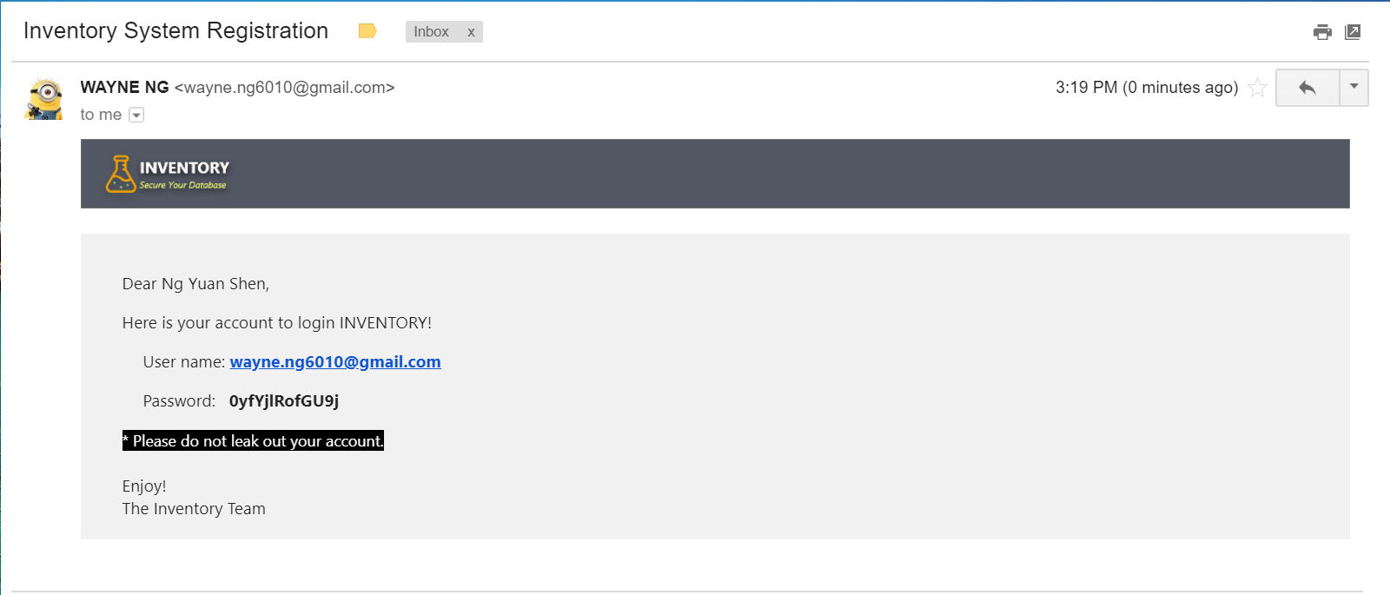

**Viewing / Editing / Deleting Admin and User**

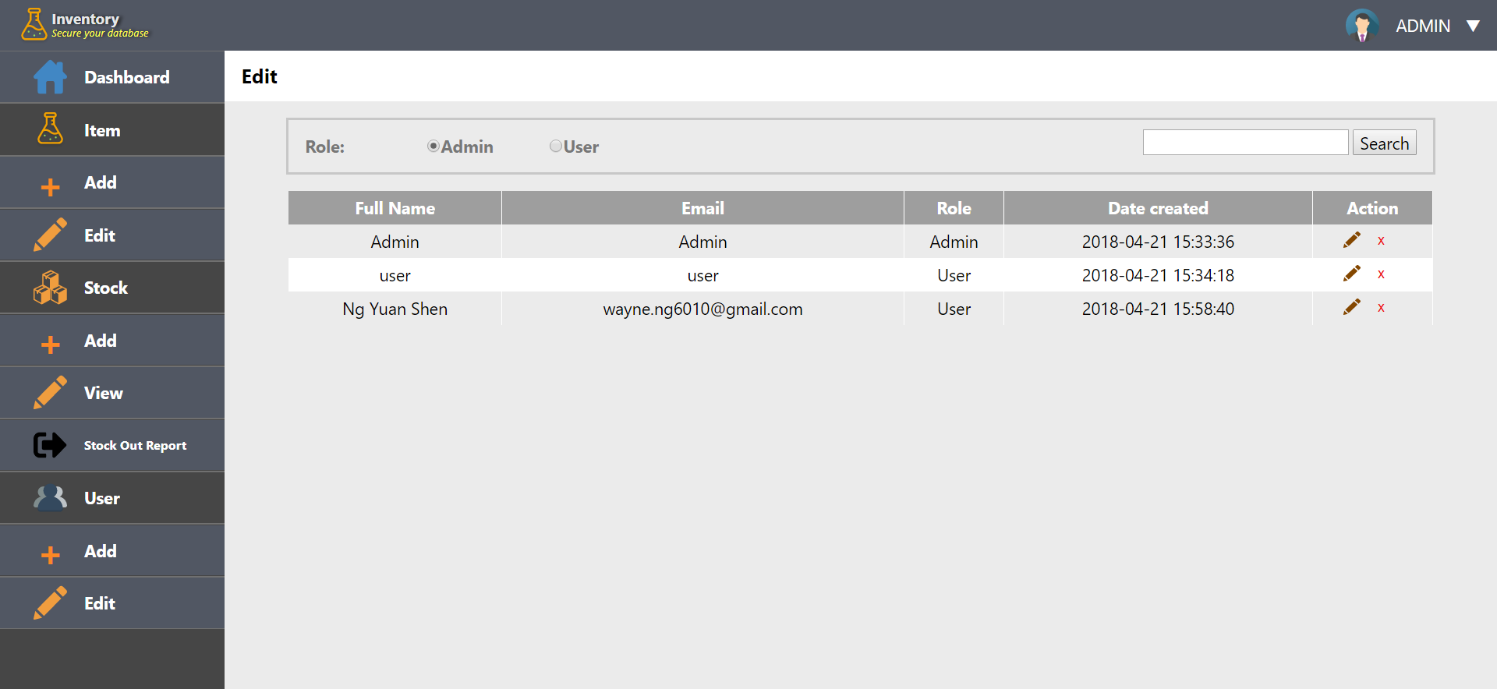

***Edit function***

When clicking on edit icon, admin will be redirected to edit page

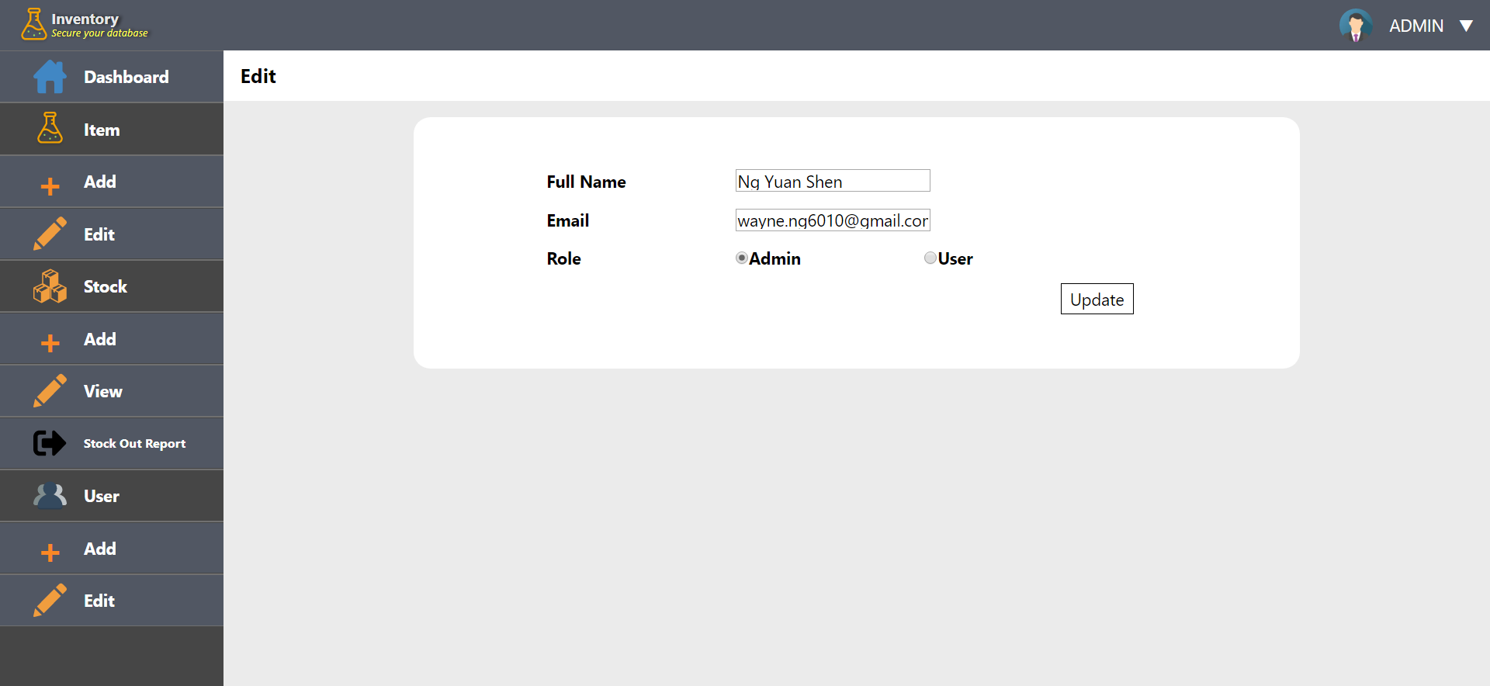

When update button is clicked

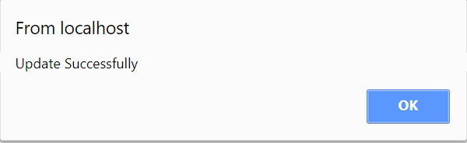

Email is changed as admin input

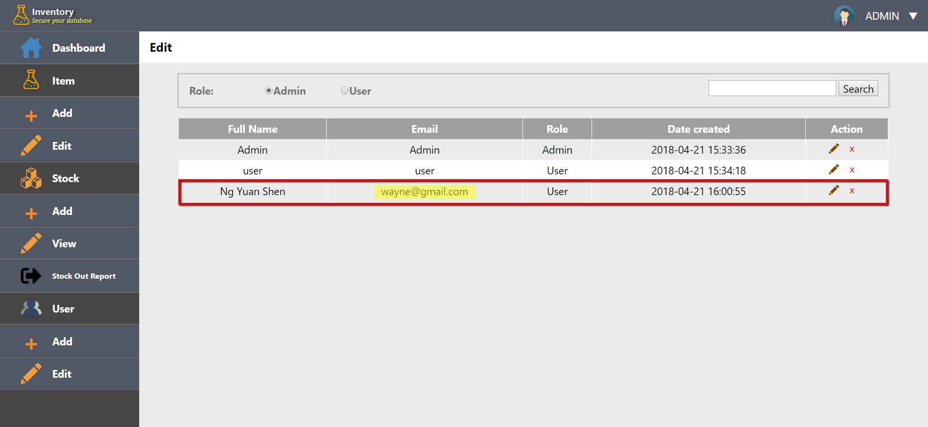

***Delete function***

When cross icon is clicked

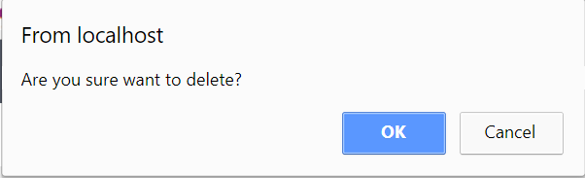

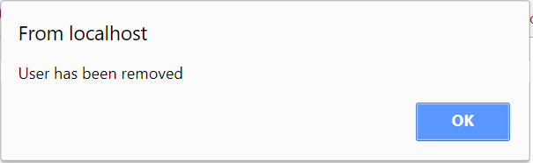

That user is removed from the record

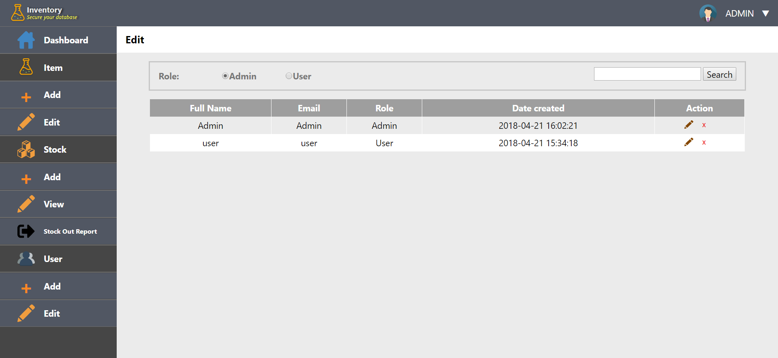

**Screenshots of Outputs (User Page)**

**Stock Up Urgent Request**

***Input***

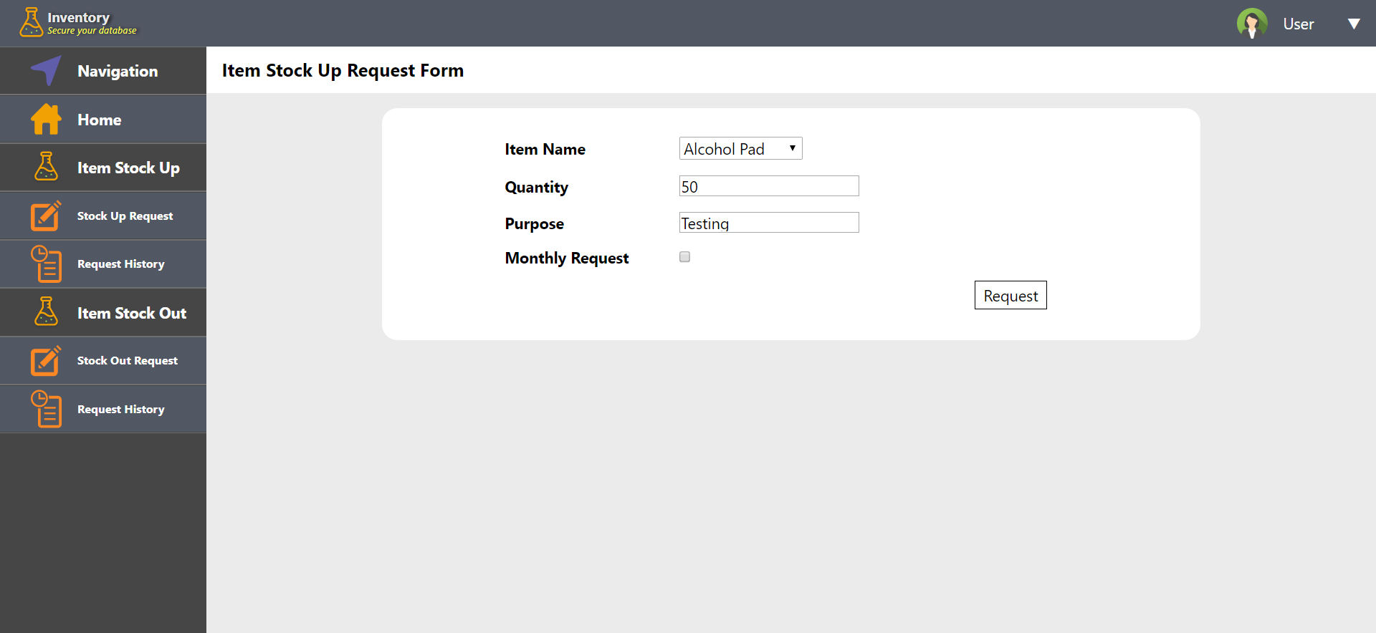

***Output***

User side

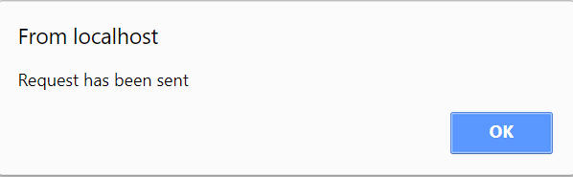

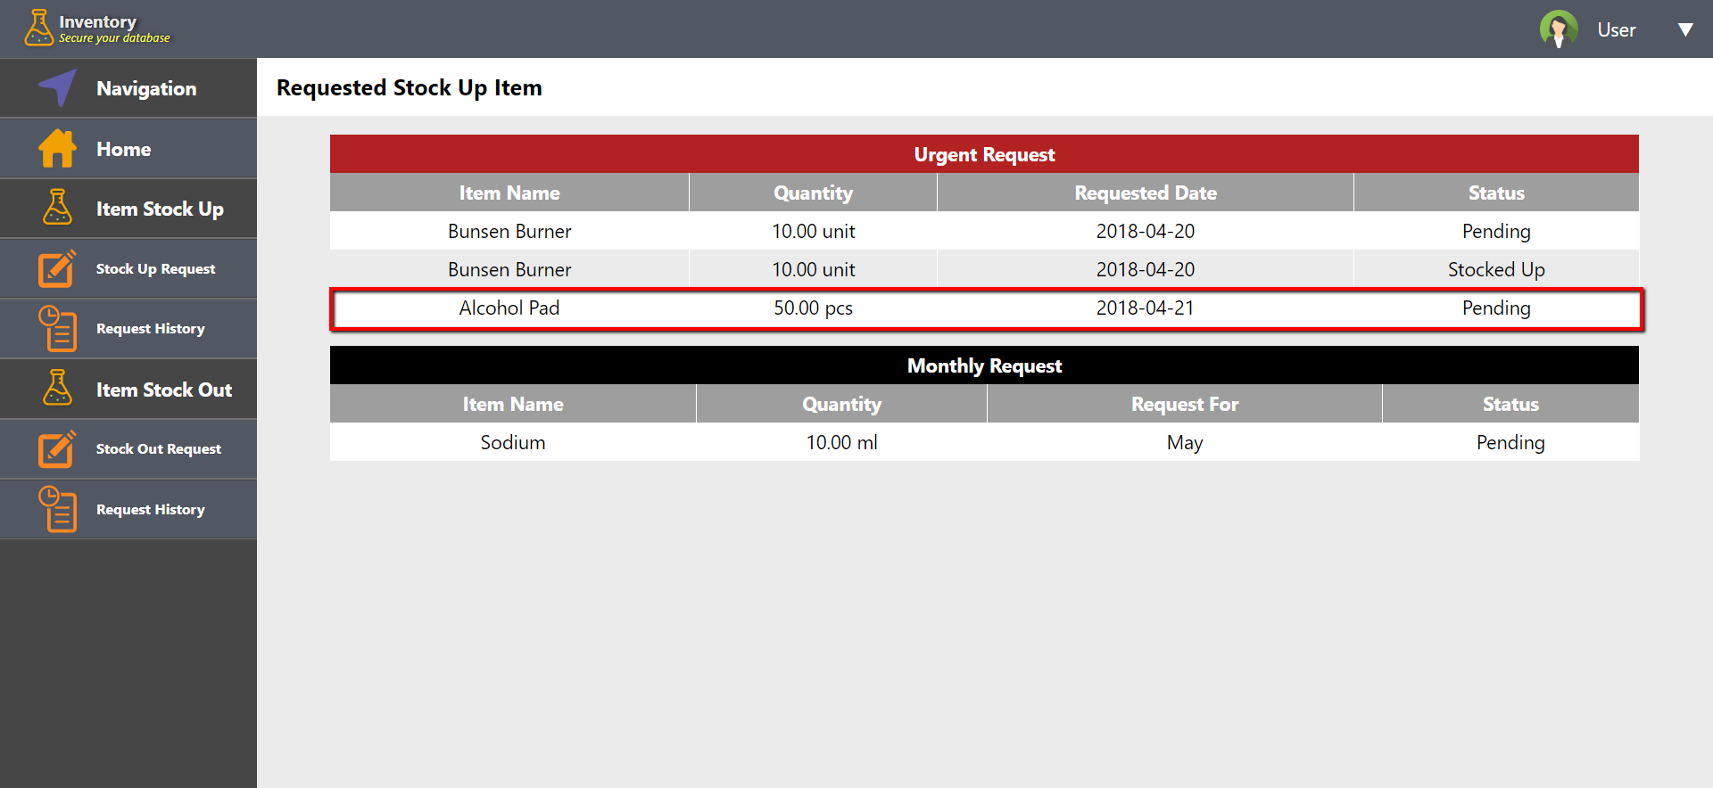

Admin Side

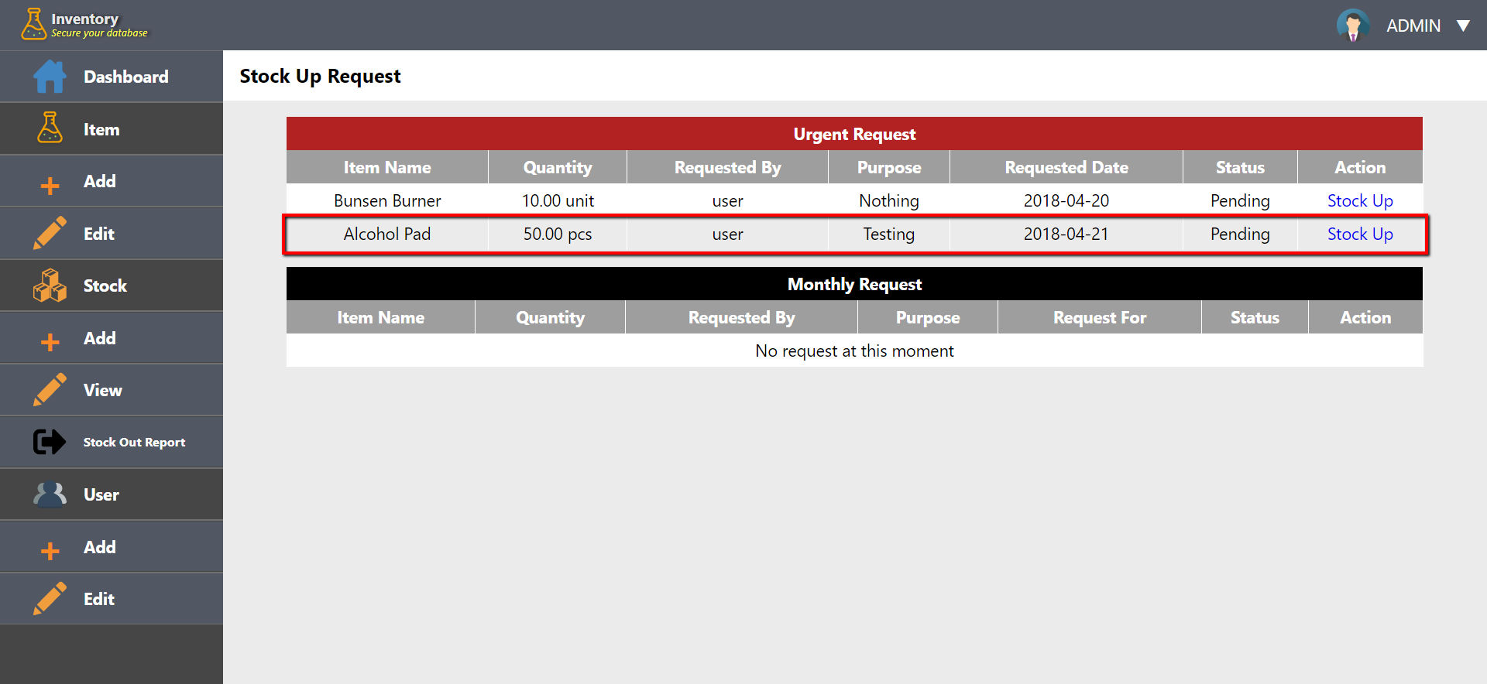

**Stock Out Request**

***Input***



***Output***

User Side

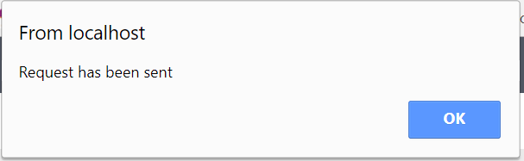

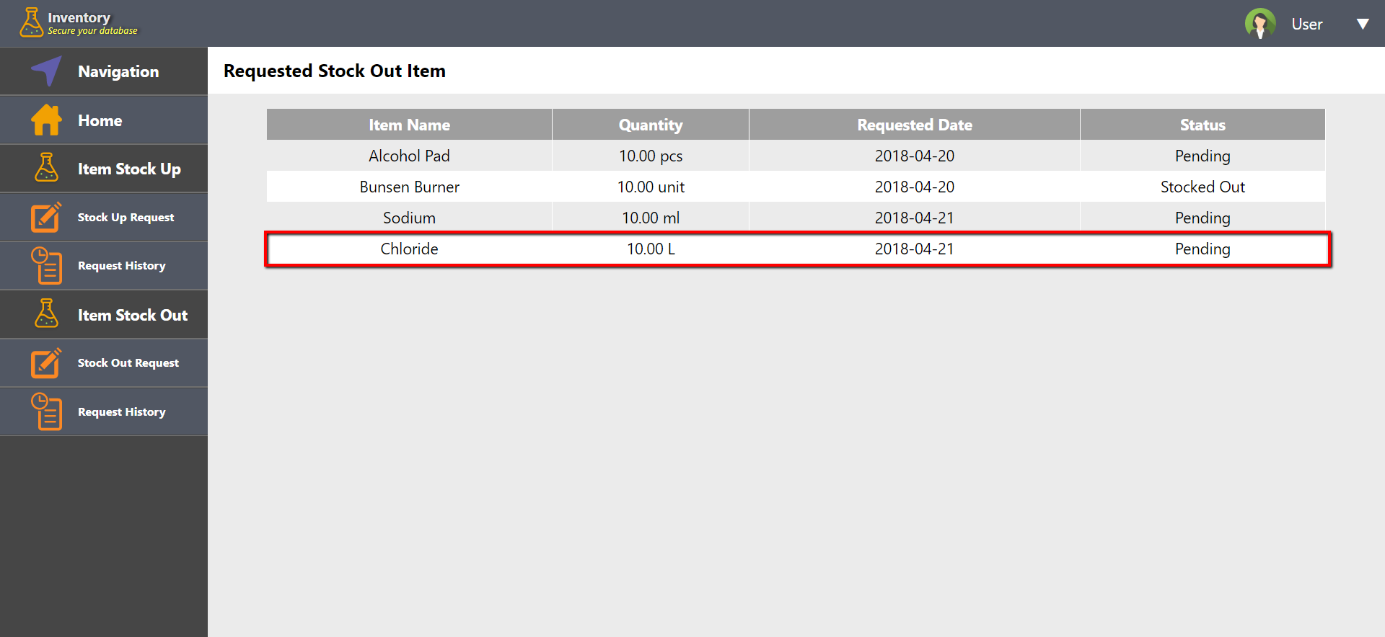

Admin Side

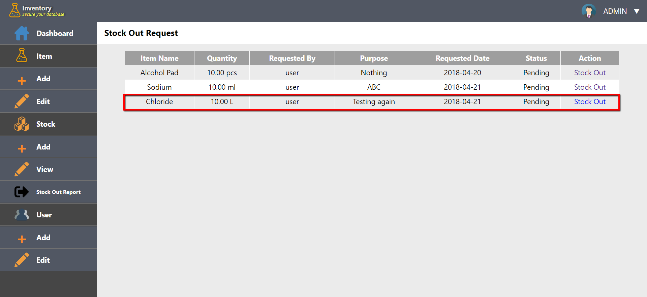

**Changing Password**

***Input***

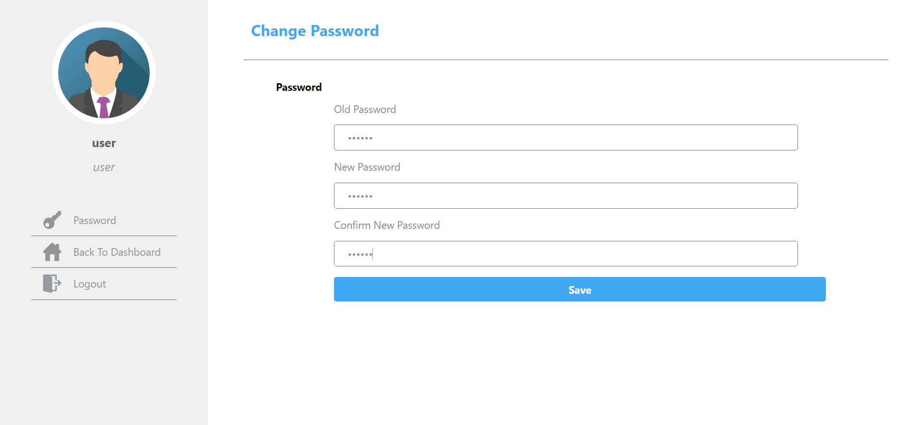

***Output***

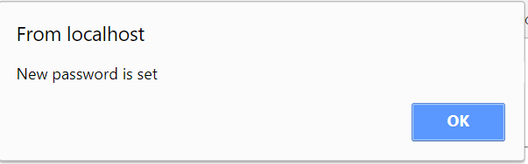

**PART B**

**Presentation Slides**

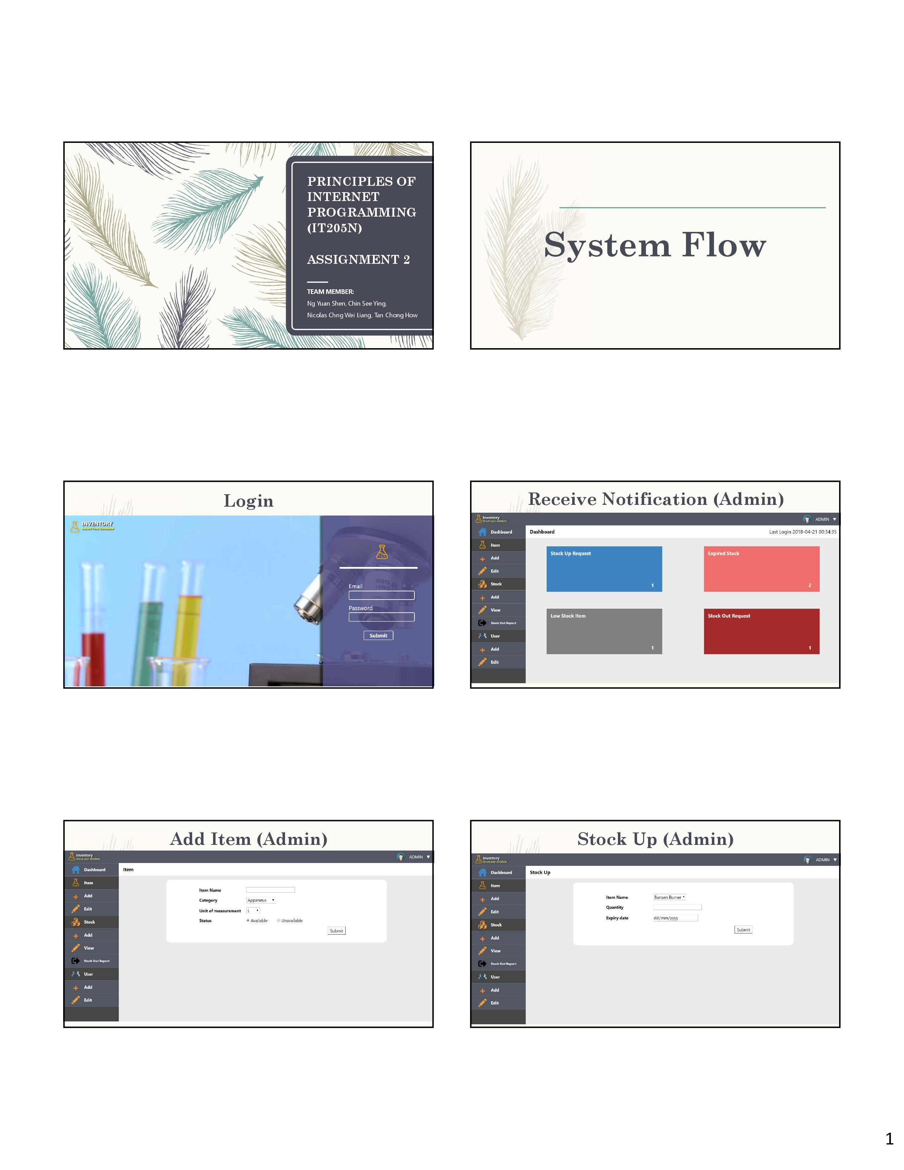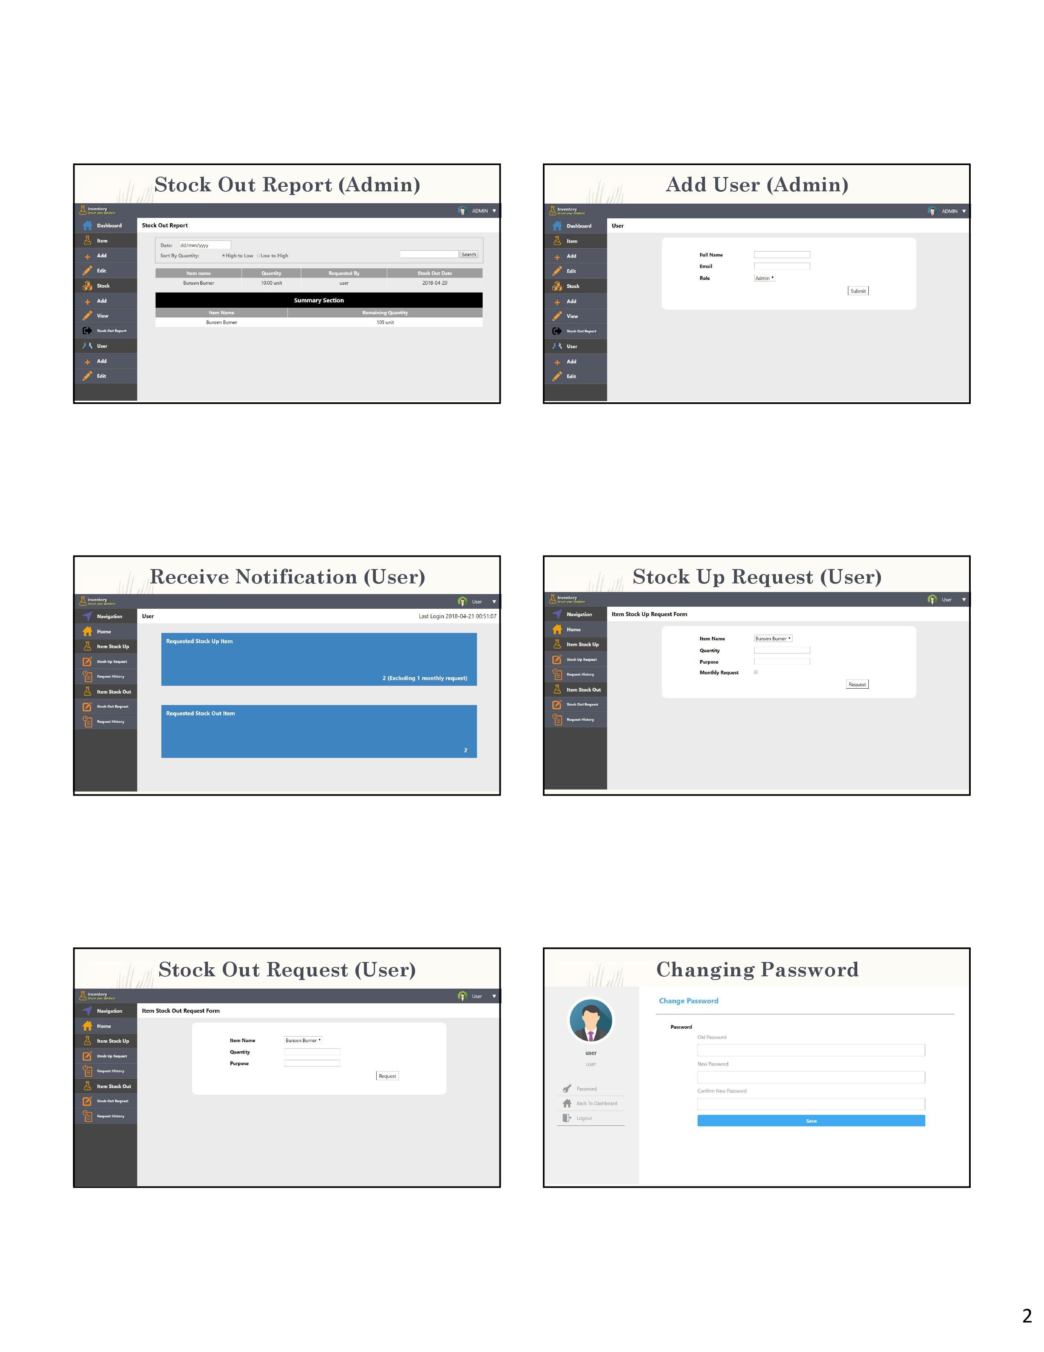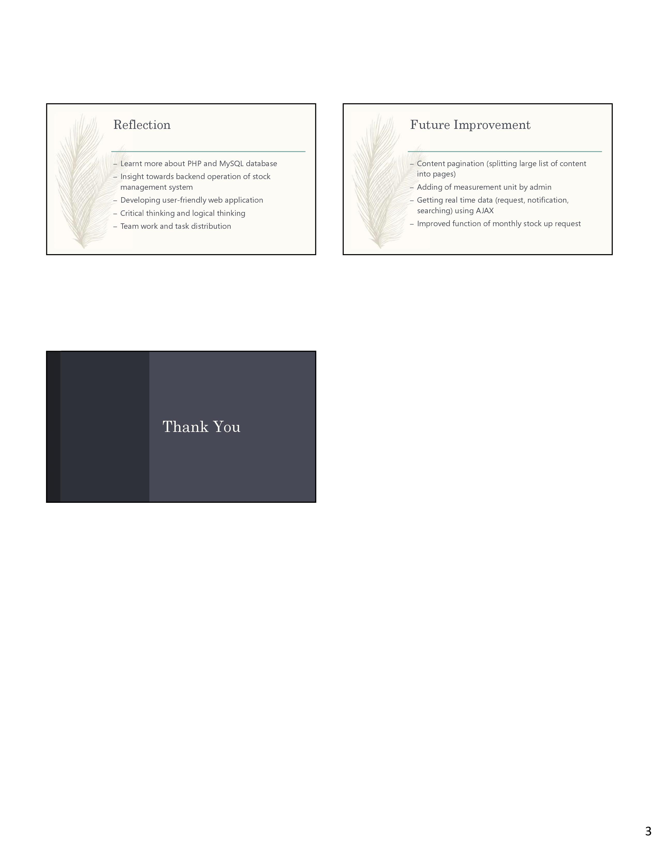

# **References**

Anon., 2012. *Counting no of rows returned by a select query.* [Online]   
Available at: https://stackoverflow.com/questions/9945755/counting-no-of-rows-returned-by-a-select-query  
[Accessed 1 April 2018].

Anon., n.d. *htmlentities.* [Online]   
Available at: http://php.net/manual/en/function.htmlentities.php  
[Accessed 15 April 2018].

Anon., n.d. *mysqli::real_escape_string.* [Online]   
Available at: http://php.net/manual/en/mysqli.real-escape-string.php  
[Accessed 15 April 2018].

Anon., n.d. *password_hash.* [Online]   
Available at: http://php.net/manual/en/function.password-hash.php  
[Accessed 29 March 2018].

Anon., n.d. *PHP 5 Date and Time.* [Online]   
Available at: https://www.w3schools.com/php/php_date.asp  
[Accessed 10 April 2018].